Azure Durable Functions | TypeScript

By Amir Mustafa. D.O.S – 09/12/2022

Private and Confidential

Type: Cloud, Serverless

Official Docs:

<https://learn.microsoft.com/en-us/azure/azure-functions/durable/quickstart-js-vscode>

<https://learn.microsoft.com/en-us/azure/azure-functions/durable/durable-functions-orchestrations?tabs=javascript>

[amirengg15@gmail.com](mailto:amirengg15@gmail.com) +91-8170954991 [LinkedIn](https://www.linkedin.com/in/amirmustafa1/) [Twitter](https://twitter.com/amir__mustafa) [GitHub](https://github.com/AmirMustafa) [YouTube](https://www.youtube.com/channel/UCiRv7SECTSF3-tXQM1IoMTw)

# 1. Introduction to Durable Function:

🡪 When we create Azure functions, normally there are different types of Triggers such as:

HTTP Trigger, Queue trigger, Time trigger, etc.

🡪 Among them there is one such Trigger called Durable functions.

## Three rules: Azure function should follow three steps:

1. Functions must be stateless
2. Functions must not call other functions
3. Functions should do only one thing well

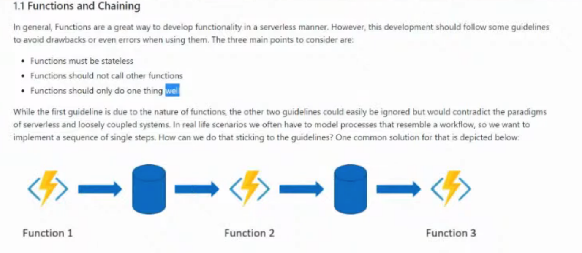

🡪 For this we will create workflow that consists of three steps.

🡪 For that we will create 3 Azure Functions. Each function will depict each step.

🡪 We will couple those functions like events or some storage entries.

Function 1 will trigger 🡪 Its results will store in Storage/ Queues

This message will be picked up via event by the second function.

🡪 This process continues until all Azure functions are executed.

🡪 So every Azure functions does their work and somehow these are loosely coupled.

🡪 Finding errors in such setup becomes complex

**Q. Can be bring something better than above solution?**

Ans. Yes, Azure Durable functions

**Q2. What is Durable Functions?**

Ans: Durable functions is not an extension to Azure function and seamlessly fits.

# 2. Mechanics of Durable Functions:

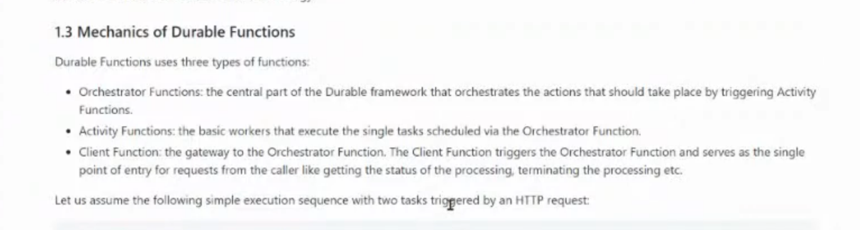

Orchestration 3 Main Triggers:

The most basic Durable Functions app contains three functions:

## Orchestrator function:

🡪 Describes a workflow that orchestrates other functions.

🡪 So basically this dispatches single activity in our work flow.

## Activity function:

🡪 Called by the orchestrator function, performs work, and optionally returns a value.

🡪 This is where single task done within Azure Functions are executed.

## Client function:

🡪 A regular Azure Function that starts an orchestrator function. This example uses an 🡪 HTTP triggered function.

This is a gateway in the world of Durable functions. This is a function we call to kick off an orchestration.

Client Function also gives us the current state of the Orchestrator

**TRICK:**

**Client Function triggers 🡪 Orchetration Function 🡪 Activity Function**

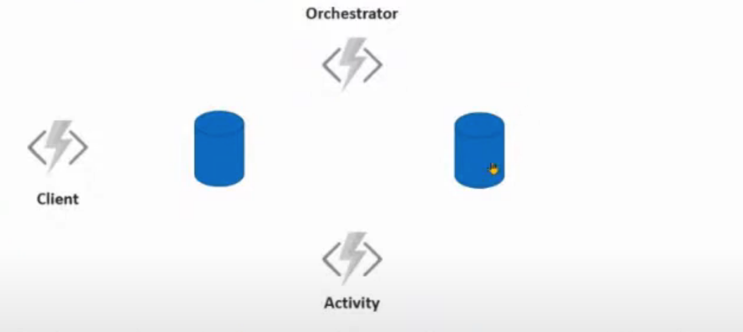

🡪 So first will make HTTP calls to Client. Client wakes up and puts the task into control Queue

🡪 So basically this makes Orchestrator aware something to do.

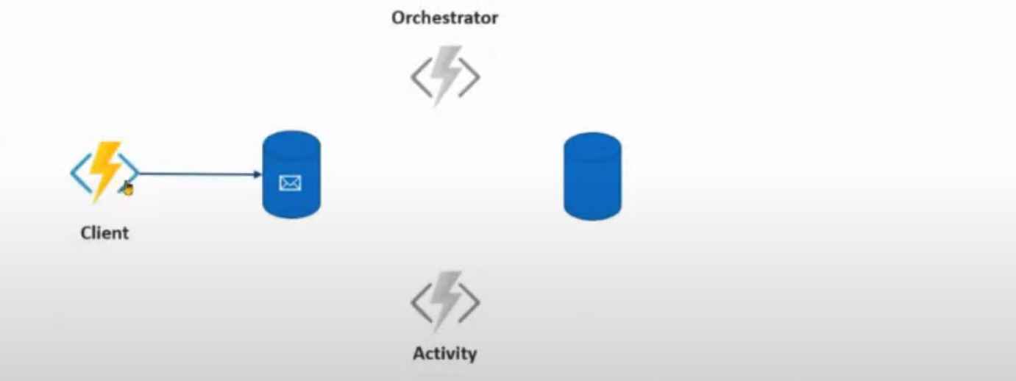

🡪 So now Client sleeps and Orchestrator wakes up

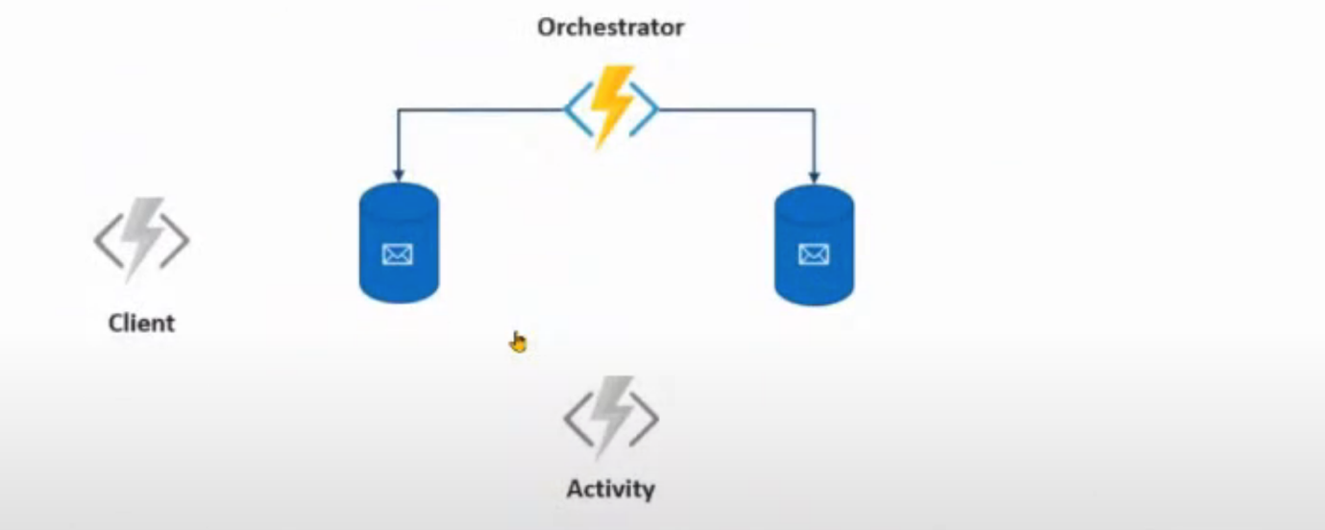

🡪 So Orchestrator picks up a task from the first queue i.e. control queue.

🡪 Orchestrator now schedule task into task cup in order to trigger the activity functions.

🡪 When the work is done OE Orchestrator function scales down to 0 and Activity Function is triggered based on the work on the queue.

🡪 The Activity function wakes up. Does its thing

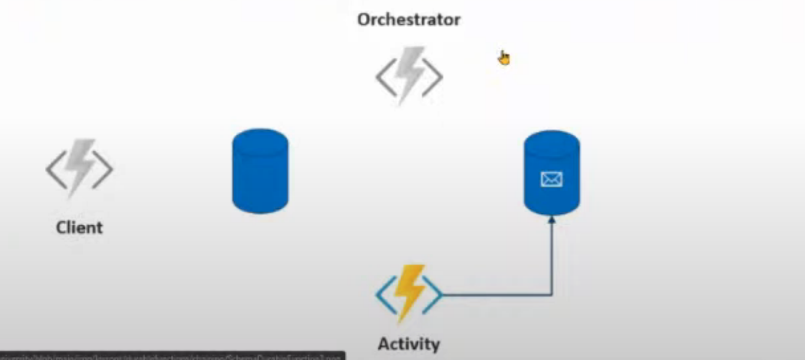

🡪 When Activity trigger work it send message to queue. Orchestrator checks whether more works need to be done

🡪 So our case Activity 2 will be triggered and finally Activity3 will be triggered

🡪 We can get all the response back finally from Client Function, when steps end.

🡪 So in short **Durable Function/Orchetrator Function / Orchestration Engine (OE)** is used when there are business process that requires certain number of process steps.

🡪 Maybe in specific sequence or things in parallel – that we want to capture in our code

# 3. Eg 1: Hello World API

🡪 Create a Project Directory. Open in VS Code:

## Step 1: Client Function | HTTP Starter:

🡪 Go to Azure Extension. Click Function sign

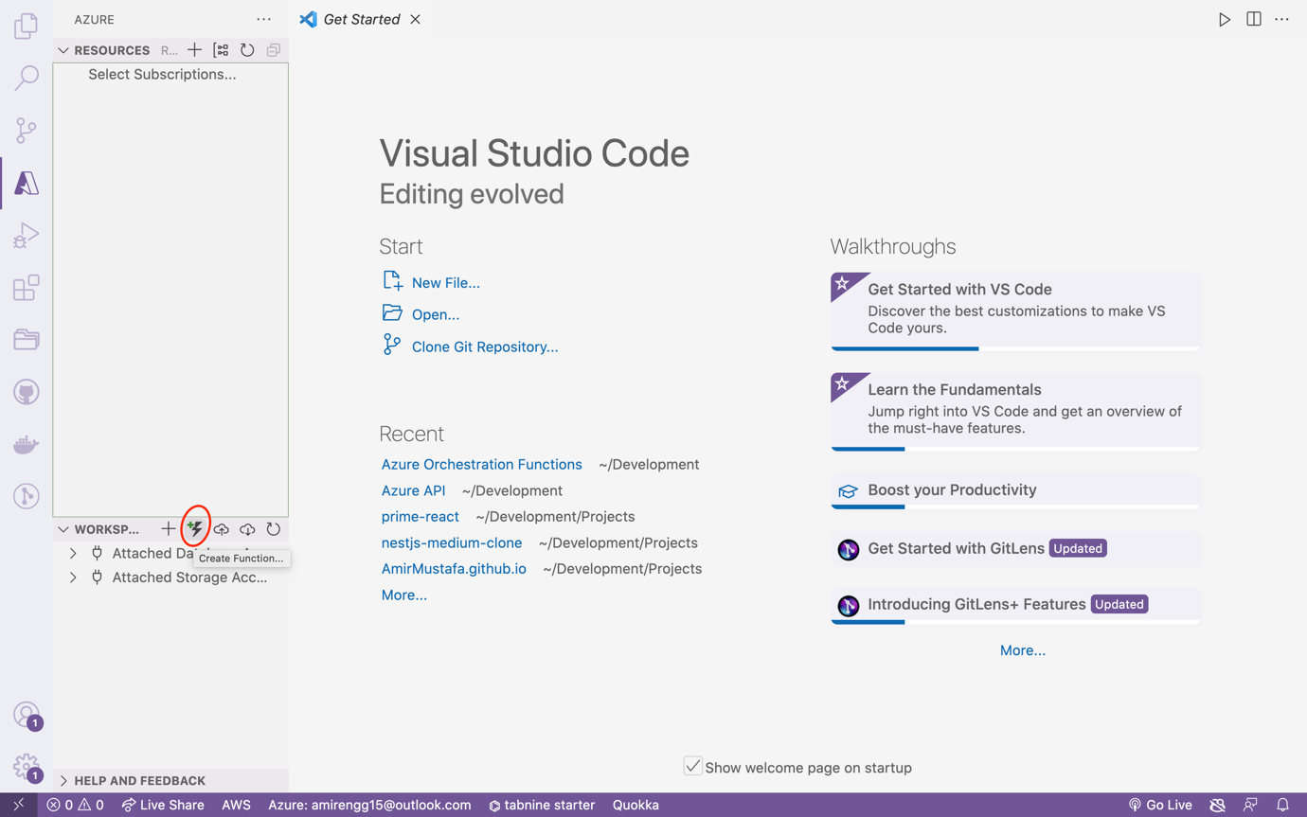

🡪 Name of our project in same path pops up. Click it

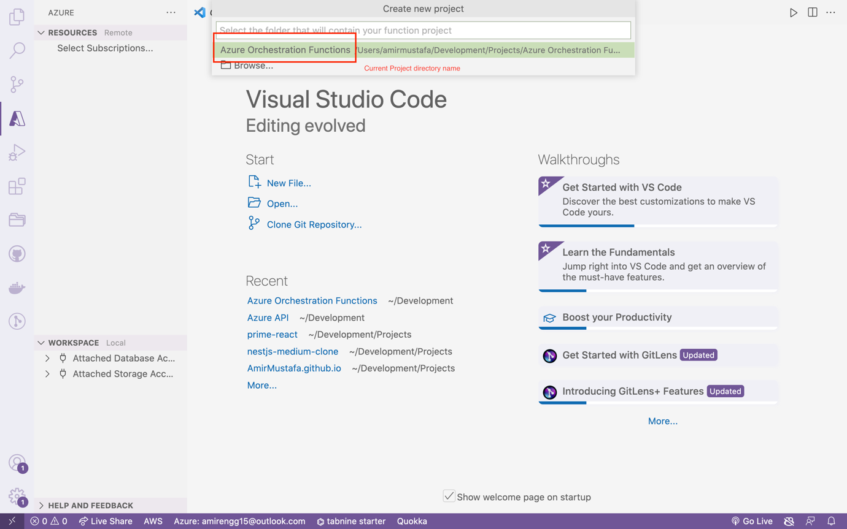

🡪 Click on your favourite programming language. We will be using Typescript

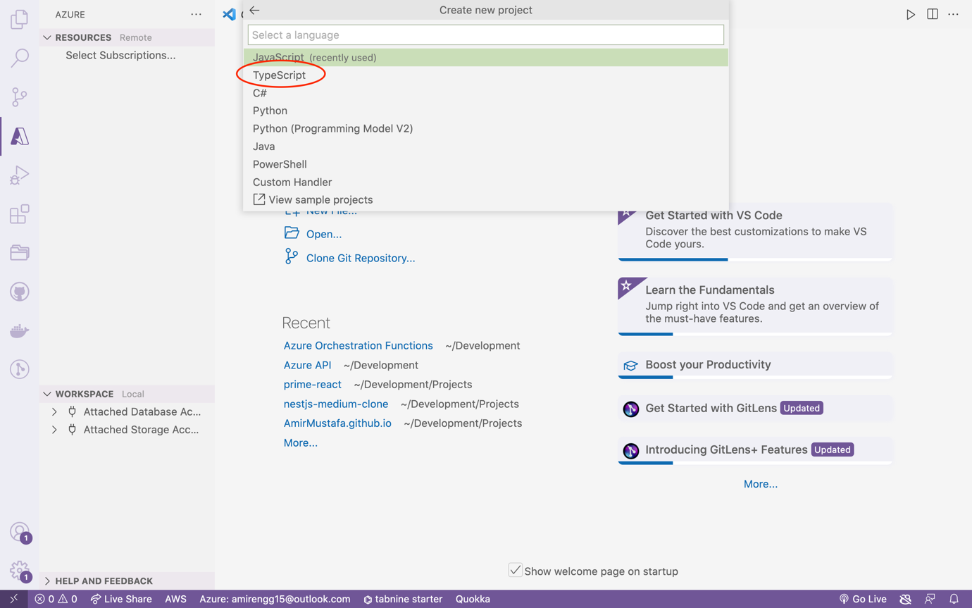

🡪 We will create couple of functions. The first function will create is **Durable Functions HTTP Starter.** Click Enter

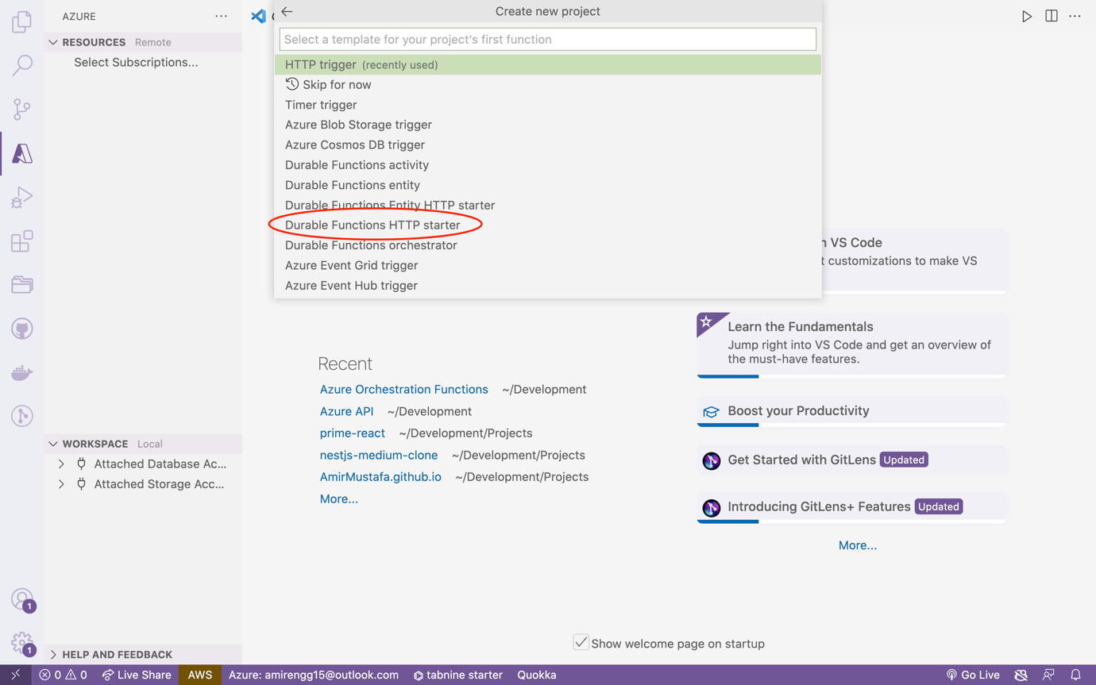

🡪Let is rename to DurableFunctionStarter. Click Enter

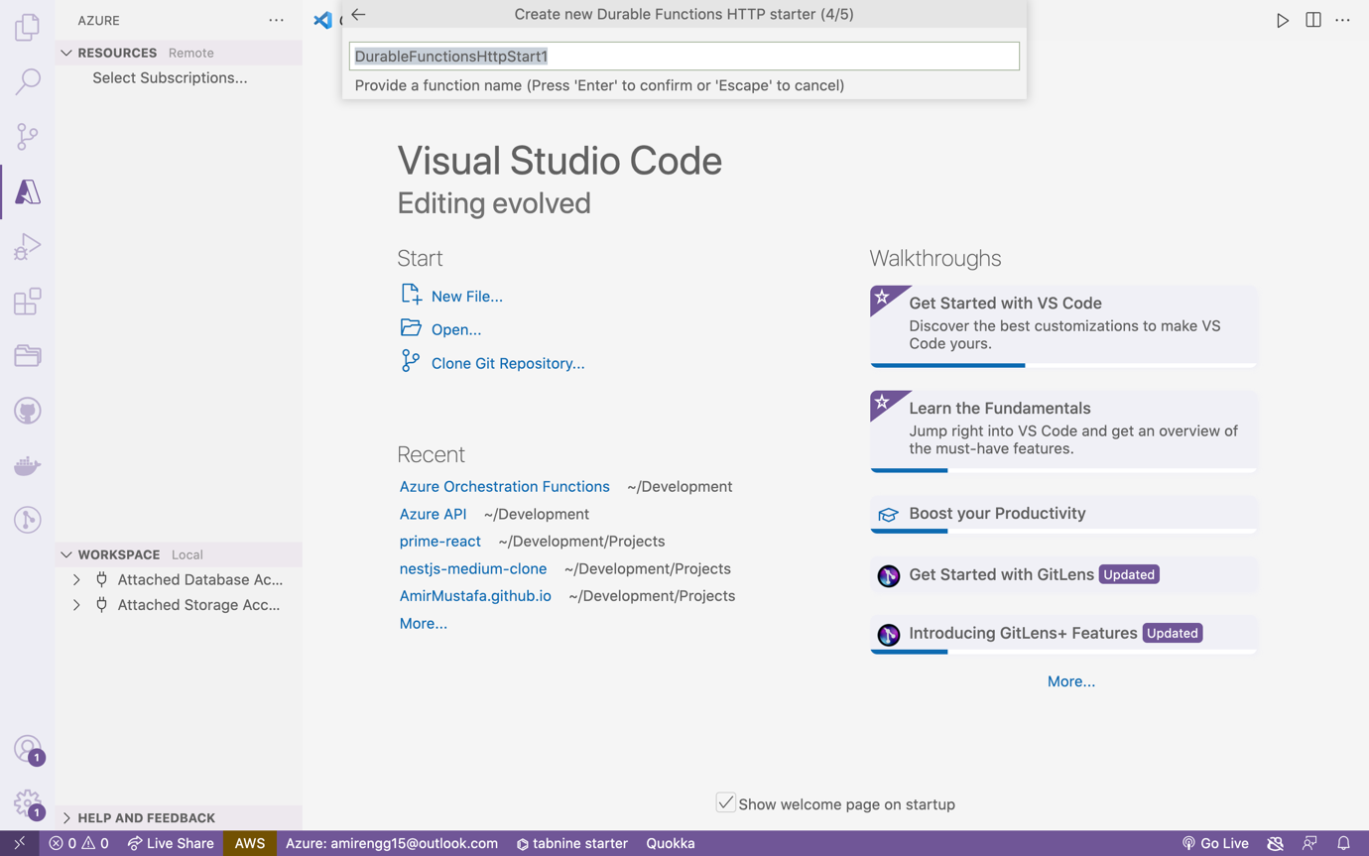

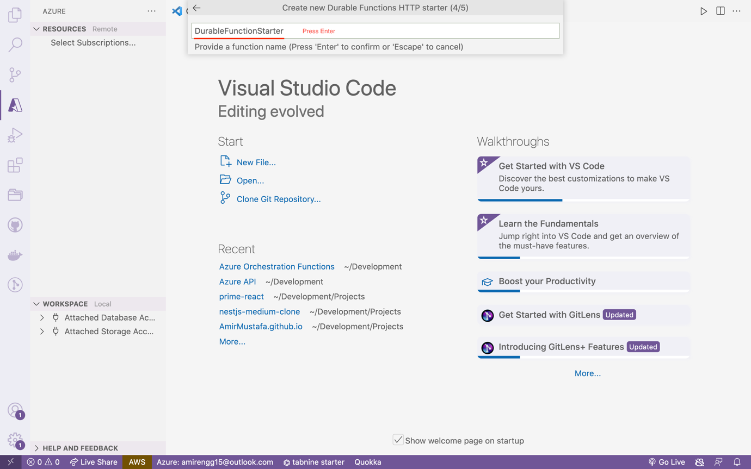

🡪 In the next step, select Anonymous. Click Enter

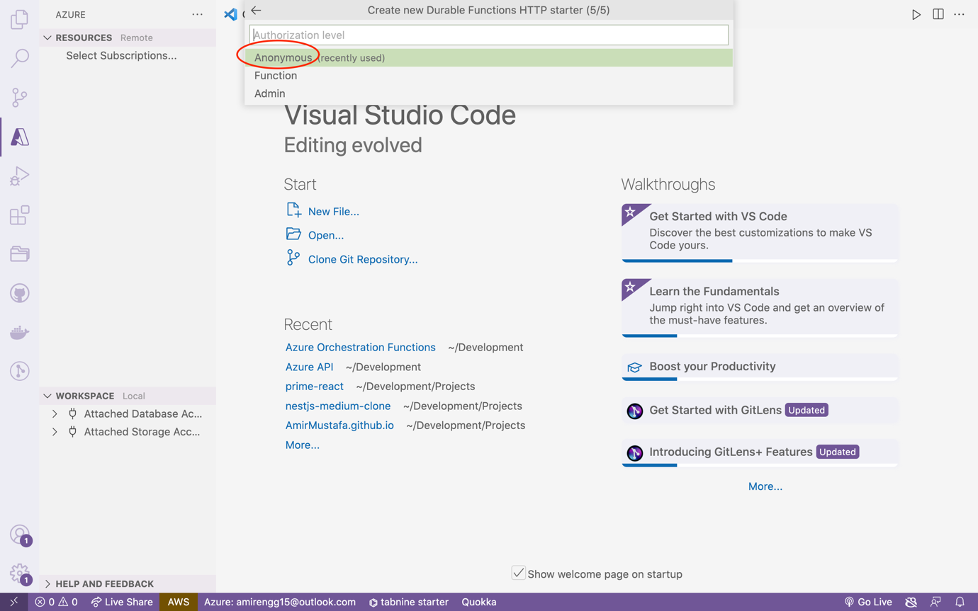

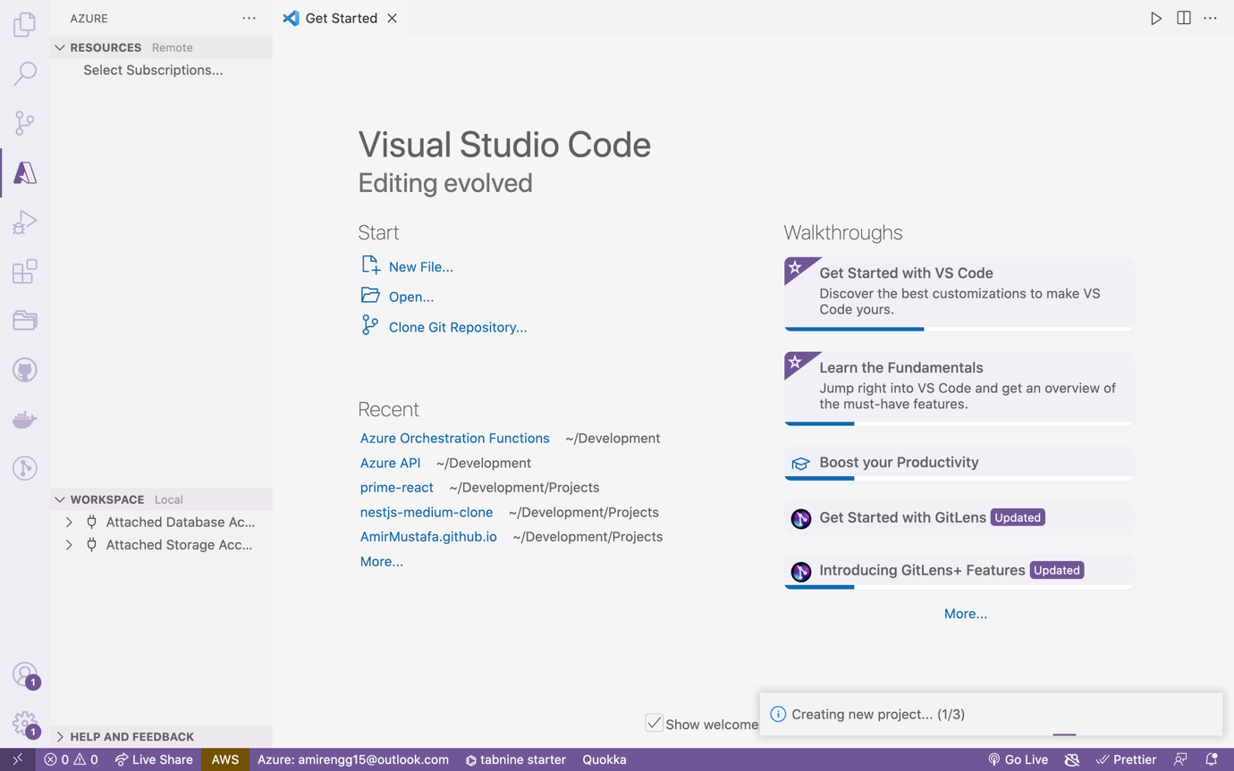

🡪 Finally our Durable function starter project created:

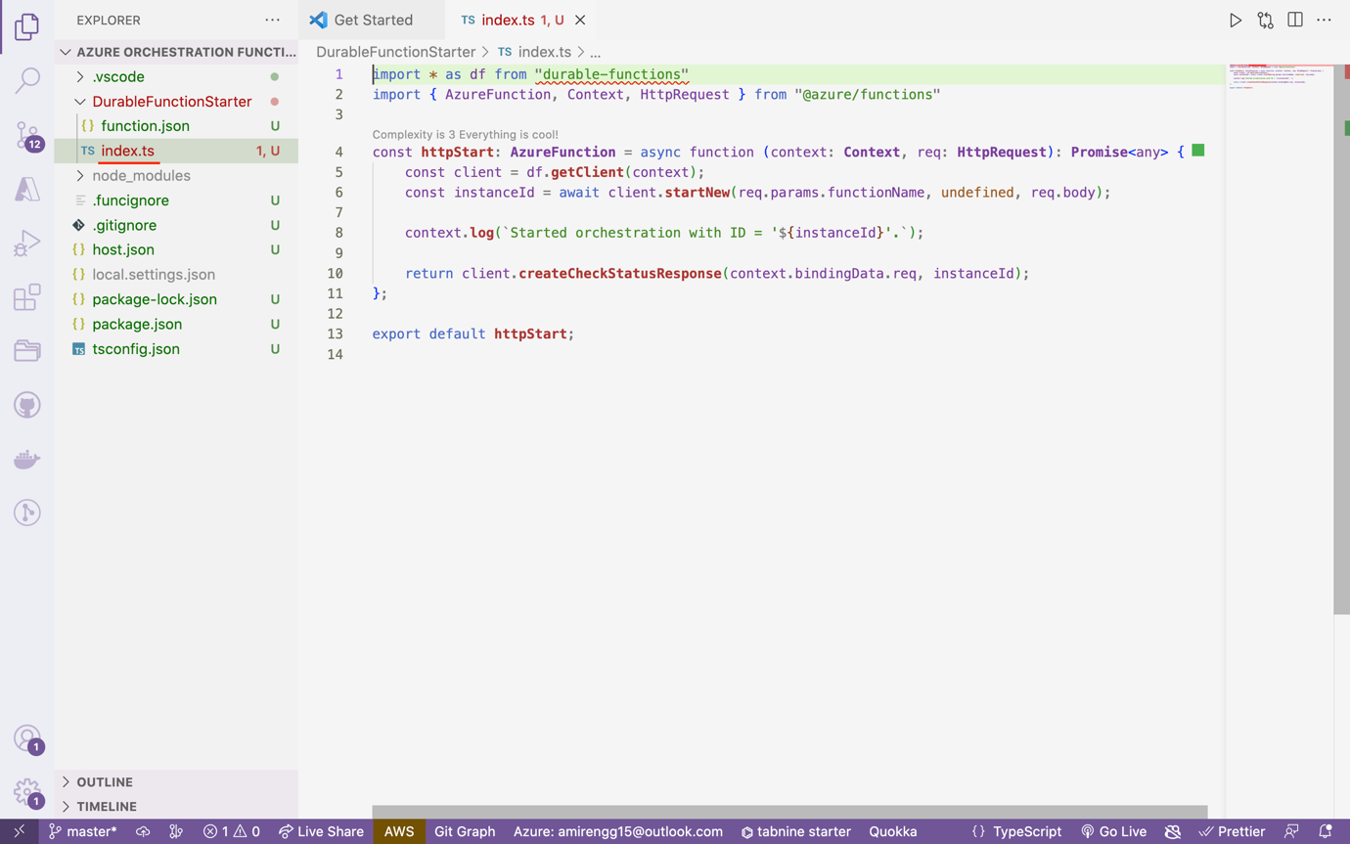

🡪 So basically two main files are – function.json (i.e. config) and index.ts (code)

### DurableFunctionStarter/function.json:

{

"bindings": [

{

"authLevel": "anonymous",

"name": "req",

"type": "httpTrigger",

"direction": "in",

"route": "orchestrators/{functionName}",

"methods": [

"post",

"get"

]

},

{

"name": "$return",

"type": "http",

"direction": "out"

},

{

"name": "starter",

"type": "orchestrationClient",

"direction": "in"

}

],

"scriptFile": "../dist/DurableFunctionStarter/index.js"

}

🡪 So this is Client Function. Client basically knows which Orchetrator function to invoke using route key.

Index.ts:

Let us now install durable-function package

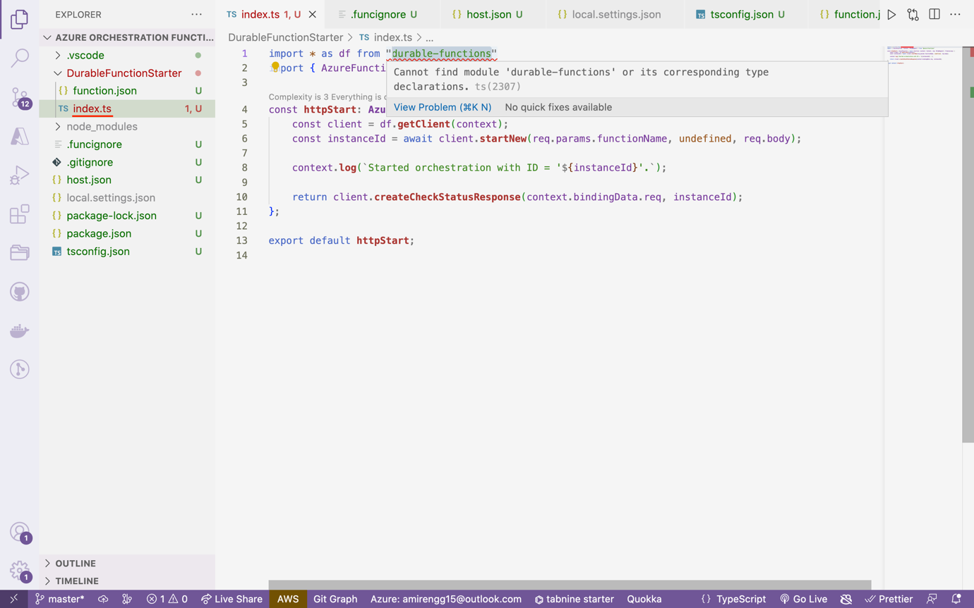

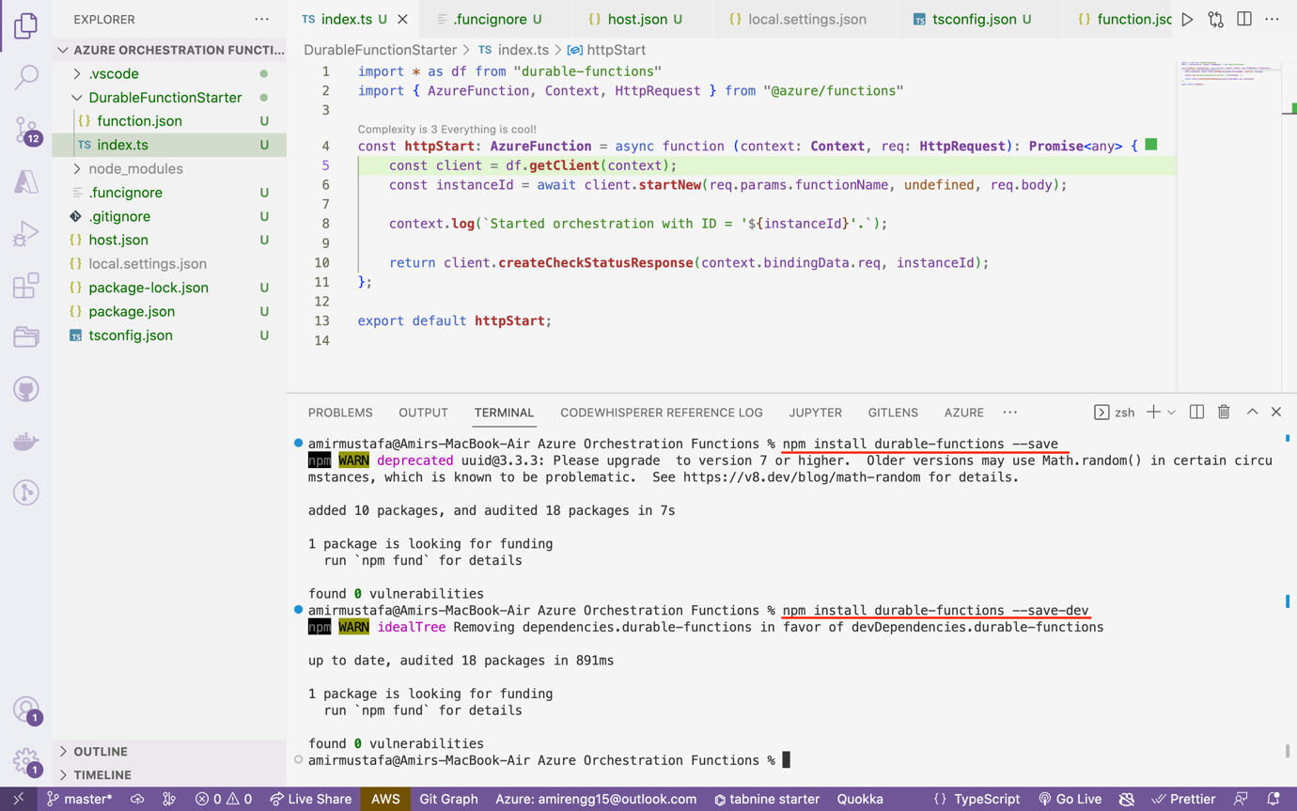

### Installing Durable functions packages:

npm install durable-functions --save

npm install @types/node –save-dev. // for typescript understanding node syntax

### DurableFunctionStarter/index.ts:

The idea of Client Function is to invoke Orchestrator function.

import * as df from "durable-functions"

import { AzureFunction, Context, HttpRequest } from "@azure/functions"

const **httpStart**: **AzureFunction** = async function (context: **Context**, req: **HttpRequest**): **Promise**<any> {

const client = df.**getClient**(context);

const instanceId = await client.**startNew**(req.params.functionName, undefined, req.body);

context.**log**(`Started orchestration with ID = '${instanceId}'.`);

return client.**createCheckStatusResponse**(context.bindingData.req, instanceId);

};

export default **httpStart**;

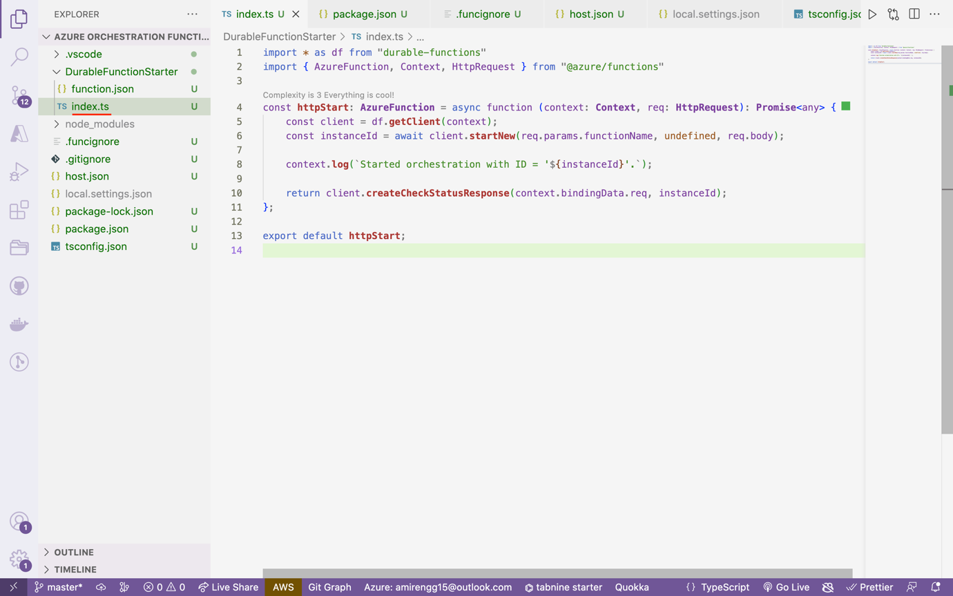

🡪 So our first function is created – Client Function (or Durable Function Starter)

## Step 2: DurableFunctionOrchestrator:

🡪 Go to Azure Extension, click Azure function create

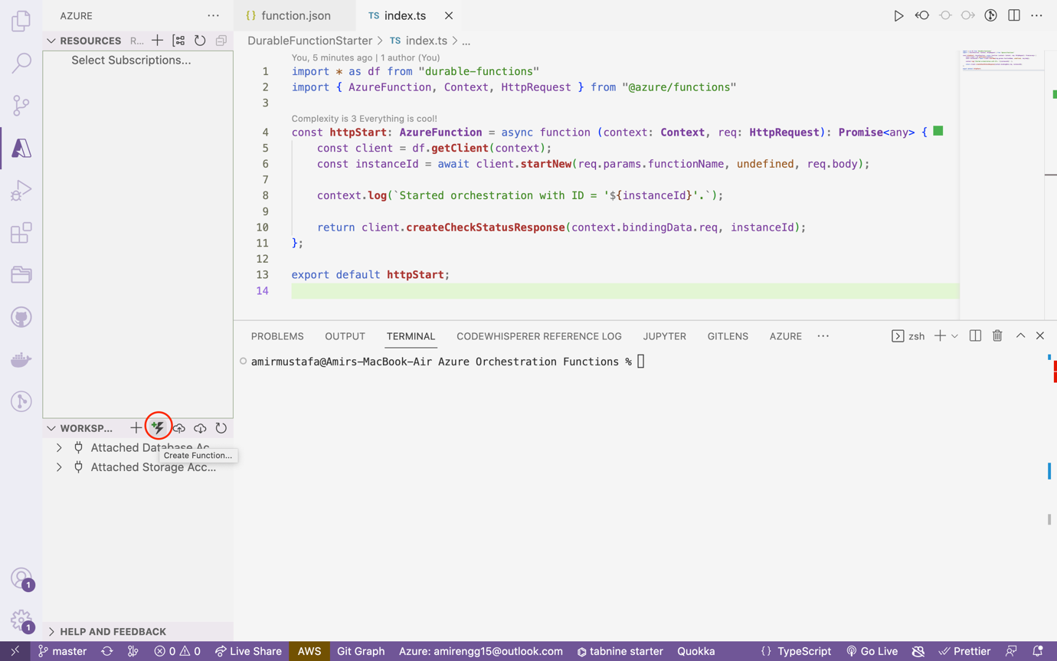

🡪 This time we select Azure Functions Orchestrator Method:

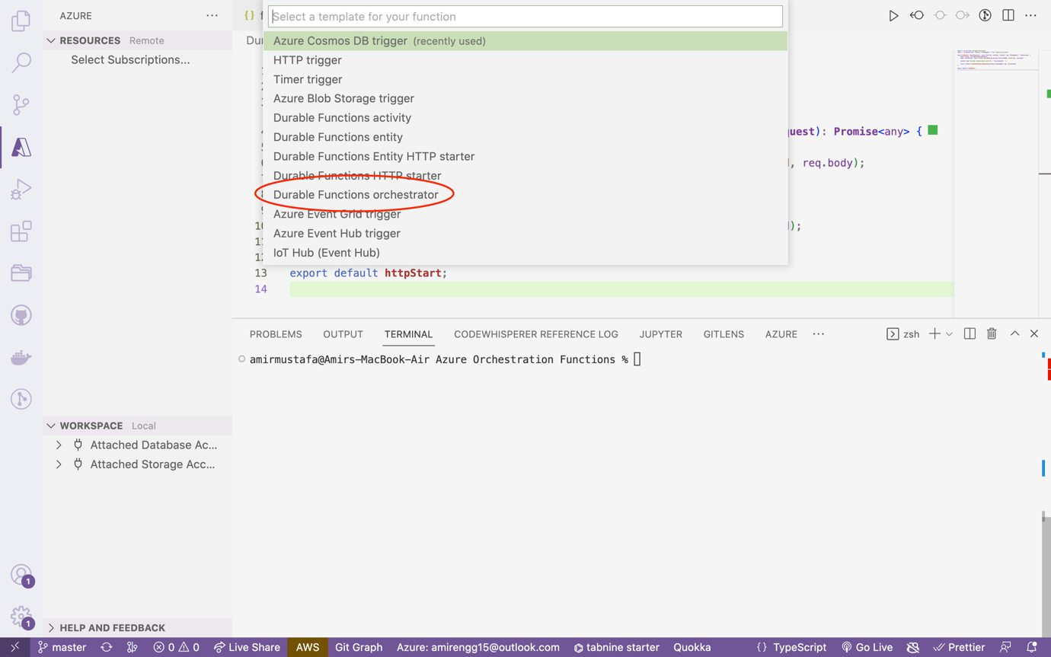

Name the Orchestrator function (say: DurableFunctionsOrchestrator)

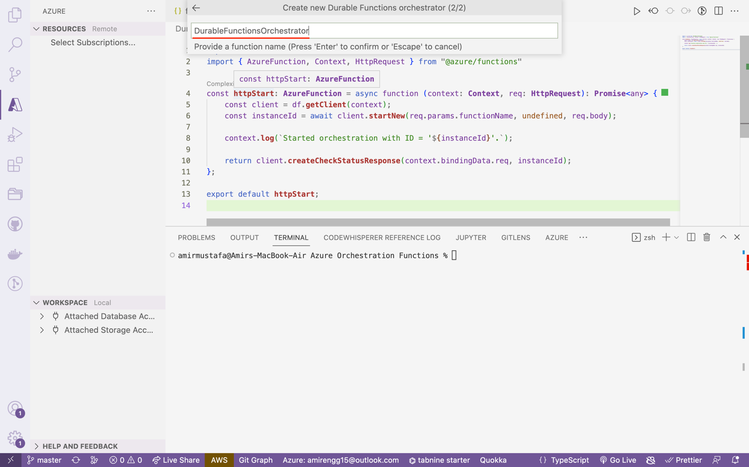

🡪 We observe our Orchestrator function is ready:

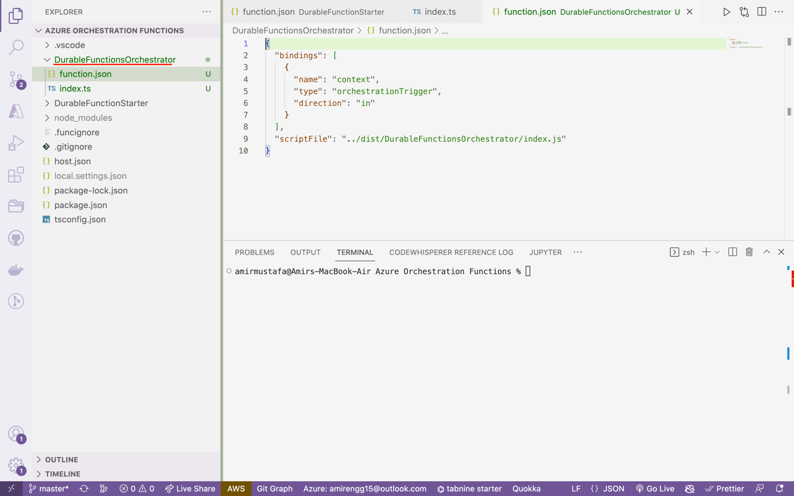

**Code Review:**

One to observe here is this is **Orchetrator Trigger**

### DurableFunctionOrchestrator/function.json

{

"bindings": [

{

"name": "context",

"type": "orchestrationTrigger",

"direction": "in"

}

],

"scriptFile": "../dist/DurableFunctionsOrchestrator/index.js"

}

### DurableFunctionOrchestrator/index.ts

*/\**

*\* This function is not intended to be invoked directly. Instead it will be*

*\* triggered by an HTTP starter function.*

*\**

*\* Before running this sample, please:*

*\* - create a Durable activity function (default name is "Hello")*

*\* - create a Durable HTTP starter function*

*\* - run 'npm install durable-functions' from the wwwroot folder of your*

*\* function app in Kudu*

*\*/*

import * as df from "durable-functions"

const **orchestrator** = df.**orchestrator**(function* (context) { // generator function

const outputs = [];

*// Replace "Hello" with the name of your Durable Activity Function.*

outputs.**push**(yield context.df.**callActivity**("Hello", "Tokyo"));

outputs.**push**(yield context.df.**callActivity**("Hello", "Seattle"));

outputs.**push**(yield context.df.**callActivity**("Hello", "London"));

*// returns ["Hello Tokyo!", "Hello Seattle!", "Hello London!"]*

return outputs;

});

export default **orchestrator**;

🡪 We have over here orchestrator function that excepts Javascript generator function

Generator functions are functions followed by asterisk - function *

The idea is it does return directly. Every yield will return value

When next is invokes

Official doc: [https://developer.mozilla.org/en-US/docs/Web/JavaScript/Reference/Statements/function*](https://developer.mozilla.org/en-US/docs/Web/JavaScript/Reference/Statements/function*)

### Generator function example

function* **yieldAndReturn**() {

yield "Y";

return "R";

yield "unreachable";

}

const gen = **yieldAndReturn**();

console.**log**(gen.**next**()); *// { value: "Y", done: false }*

console.**log**(gen.**next**()); *// { value: "R", done: true }*

console.**log**(gen.**next**()); *// { value: undefined, done: true }*

🡪 The idea of orchestrator function is to run sequentially i.e. functions in steps

🡪 So basically in index file we call activity function using generator function

DurableFunctionOrchestrator/index.ts:

import * as df from "durable-functions";

const **orchestrator** = df.**orchestrator**(function* (context) {

const outputs = [];

*// Replace "Hello" with the name of your Durable Activity Function.*

outputs.**push**(yield context.df.**callActivity**("Hello", "Tokyo"));

outputs.**push**(yield context.df.**callActivity**("Hello", "Seattle"));

outputs.**push**(yield context.df.**callActivity**("Hello", "London"));

*// returns ["Hello Tokyo!", "Hello Seattle!", "Hello London!"]*

return outputs;

});

export default **orchestrator**;

## Step 3: Creating Activity Trigger:

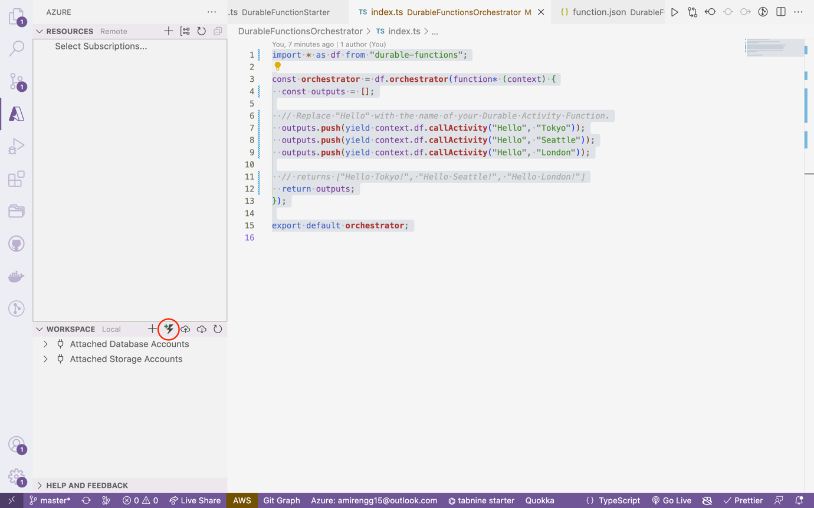

🡪 This time we select Durable Functions activity

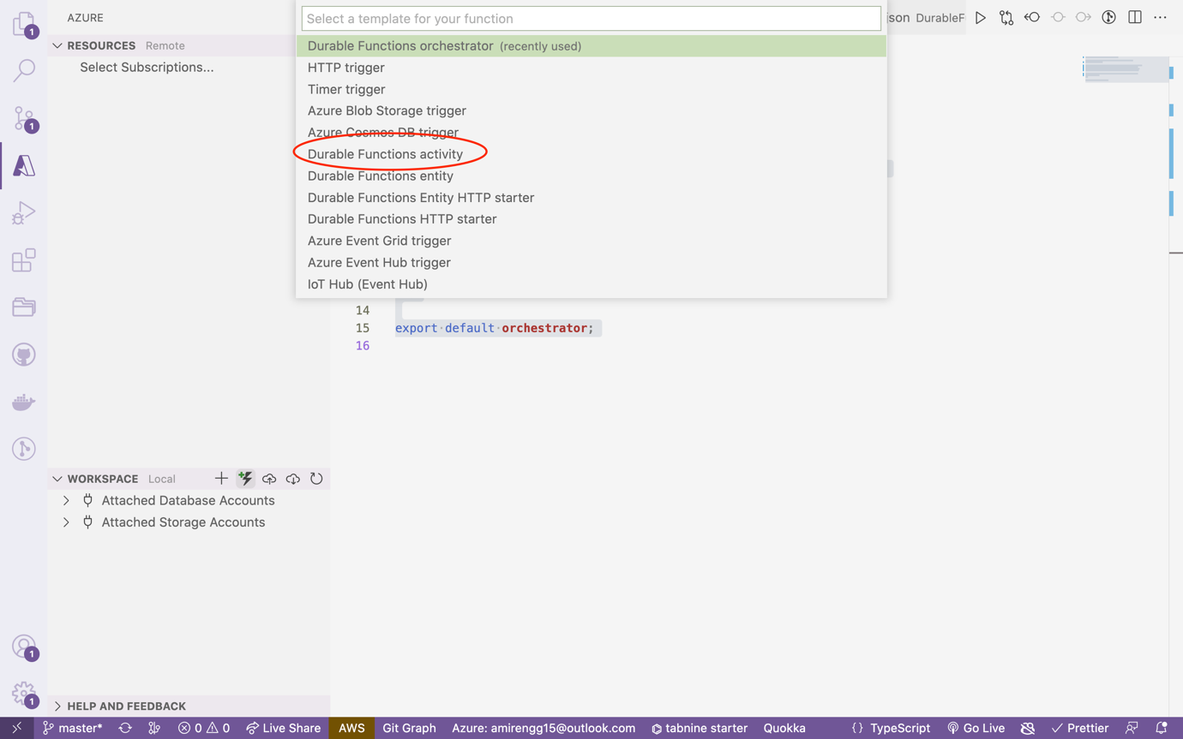

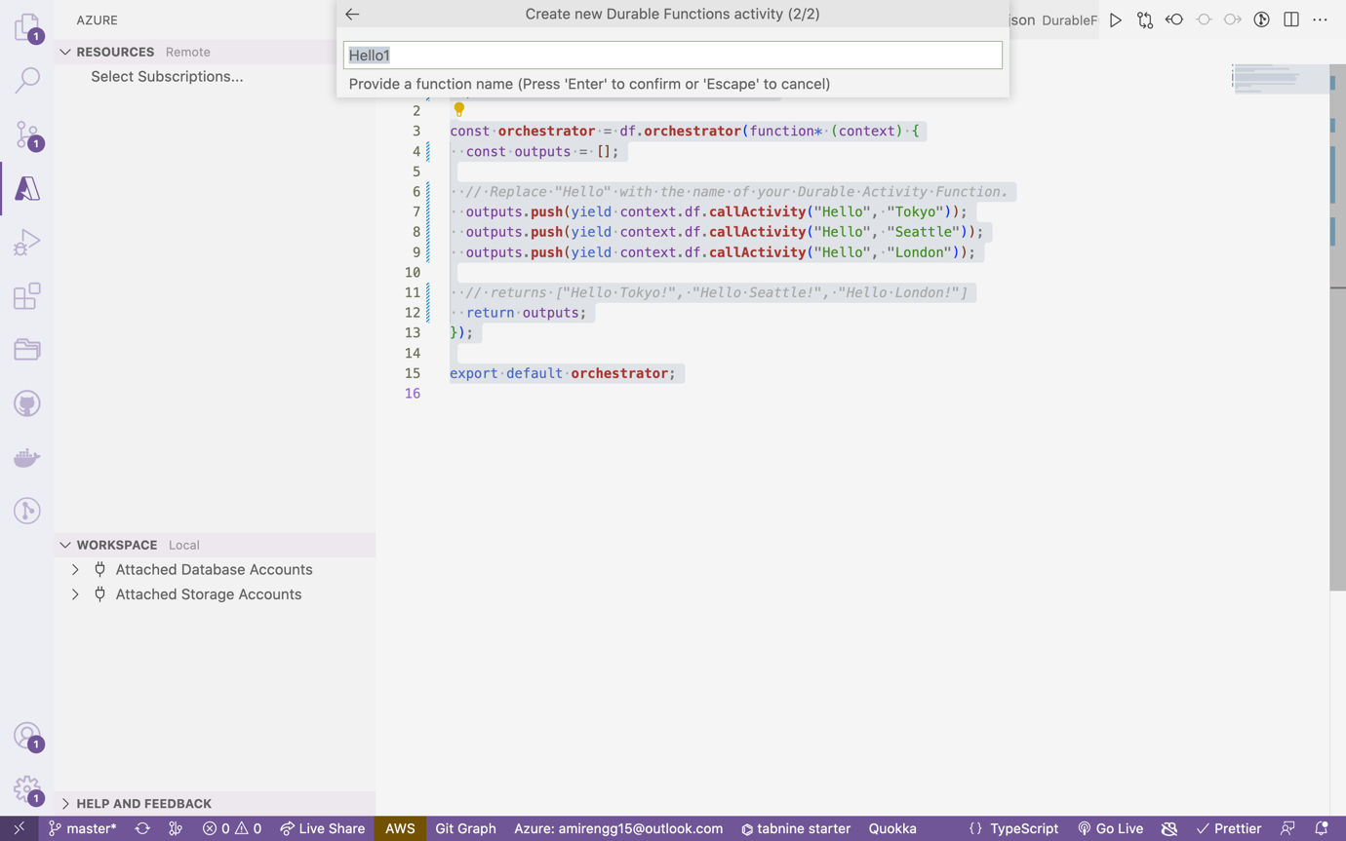

🡪 Let us name activity trigger as - HelloCity

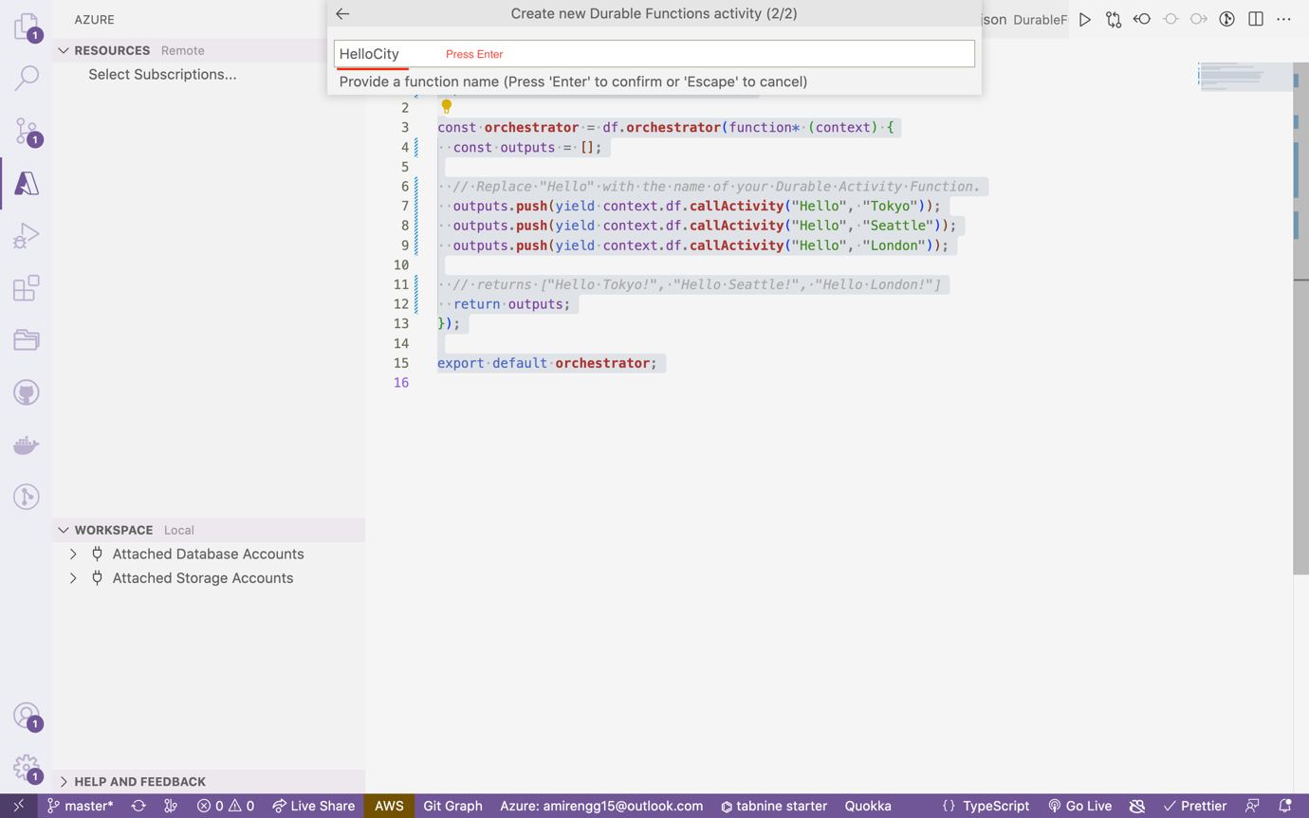

HelloCity/function.json

{

"bindings": [

{

"name": "name",

"type": "activityTrigger",

"direction": "in"

}

],

"scriptFile": "../dist/HelloCity/index.js"

}

HelloCity/index.ts

*/\**

*\* This function is not intended to be invoked directly. Instead it will be*

*\* triggered by an orchestrator function.*

*\**

*\* Before running this sample, please:*

*\* - create a Durable orchestration function*

*\* - create a Durable HTTP starter function*

*\* - run 'npm install durable-functions' from the wwwroot folder of your*

*\* function app in Kudu*

*\*/*

import { AzureFunction, Context } from "@azure/functions"

const **activityFunction**: **AzureFunction** = async function (context: **Context**): **Promise**<string> {

return `Hello ${context.bindings.name}!`;

};

export default **activityFunction**;

## Step 4: Azurite – Storage Explorer Local Emulator:

🡪 Azurite is a local emulator for testing.

🡪 Suppose free trial of Azure is over or paid subscription, we can still develop in azurite

🡪 Now we have to install emulator for Azure

npm install -g azurite

## Step 5: Project/local.settings.json:

🡪 This is a sensitive file of Orchestration where sensitive information is kept.

🡪 This is similar to .env file of node

🡪 Data is accessed to process.env file

Mainly UseDevelopmentStorage=true command triggers in storage accounts:

"AzureWebJobsStorage": "UseDevelopmentStorage=true

{

"IsEncrypted": false,

"Values": {

"AzureWebJobsStorage": "UseDevelopmentStorage=true",

"FUNCTIONS_WORKER_RUNTIME": "node"

}

}

## Step 6: Azurite Plugin VSC:

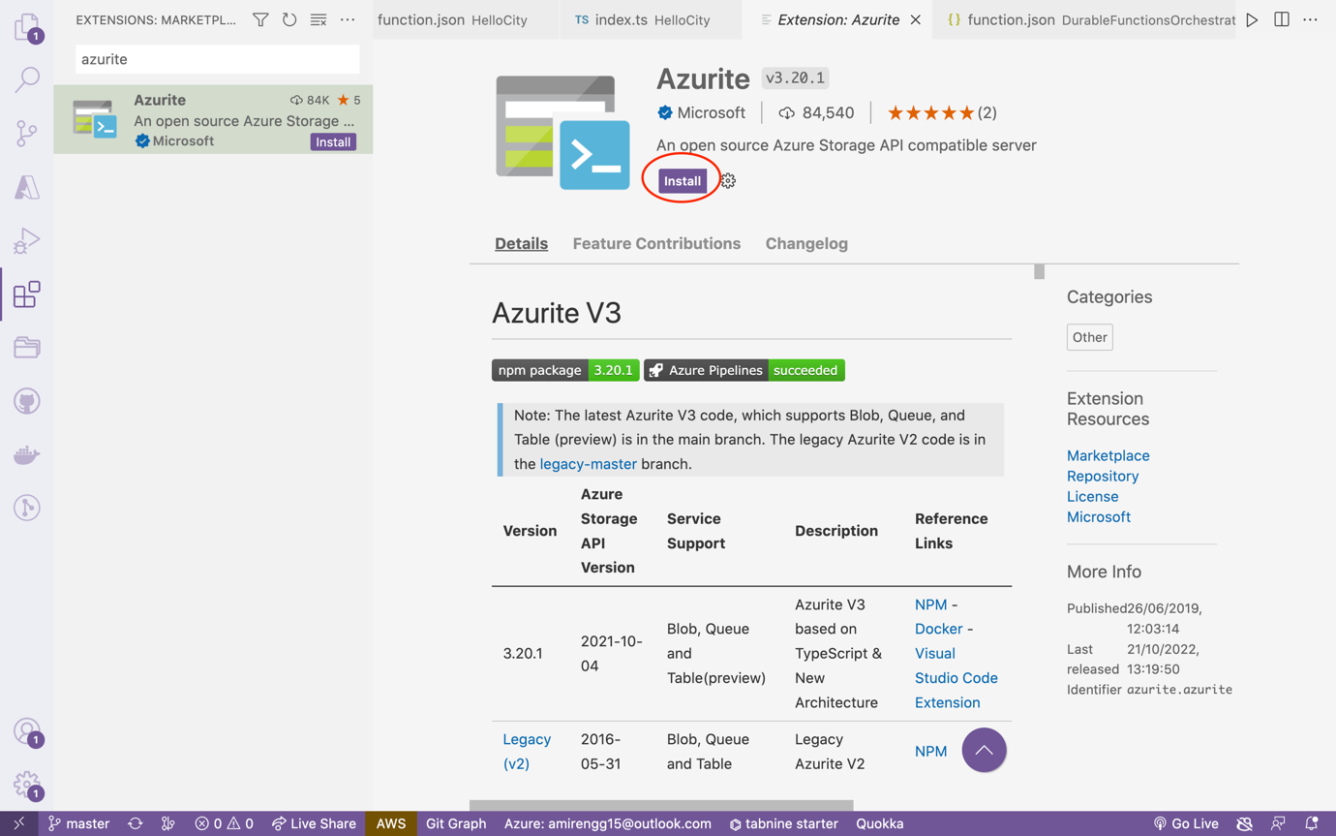

🡪 Way1: In Visual Studio Code:

Cmd + Shift + P, search Azurite

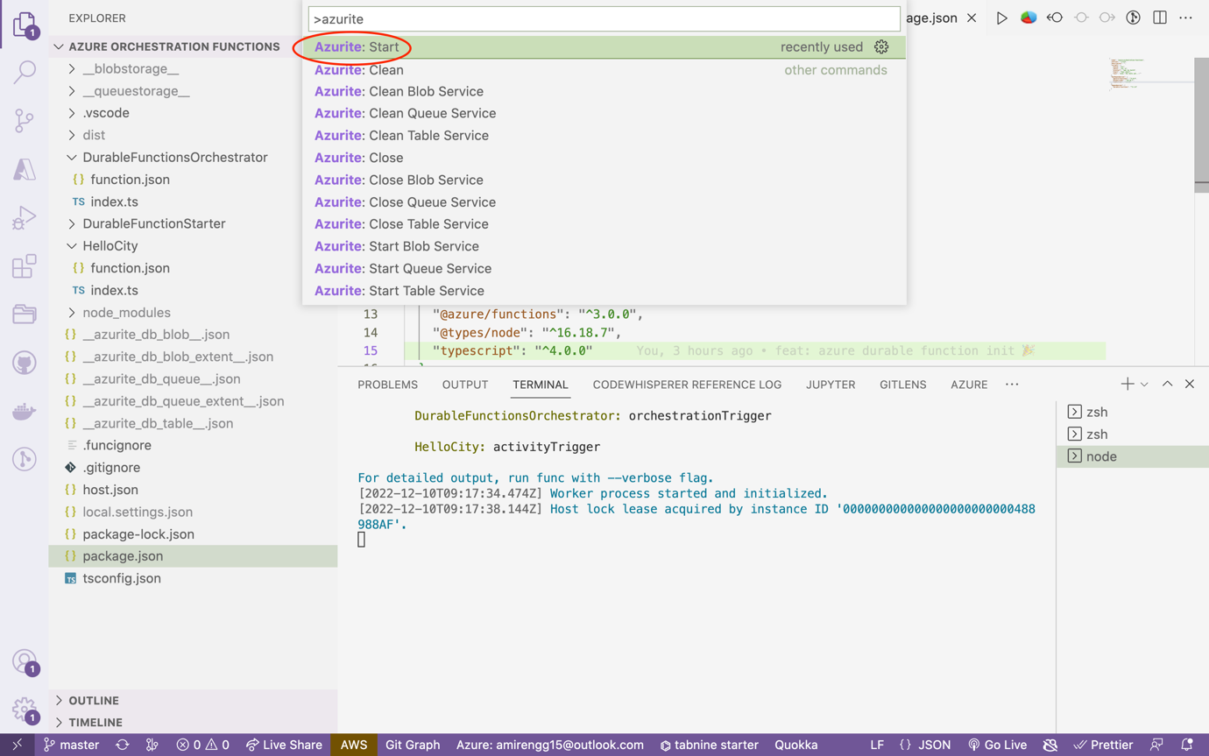

🡪 This will start all emulator locally – blob, table, queue, file share storage locally

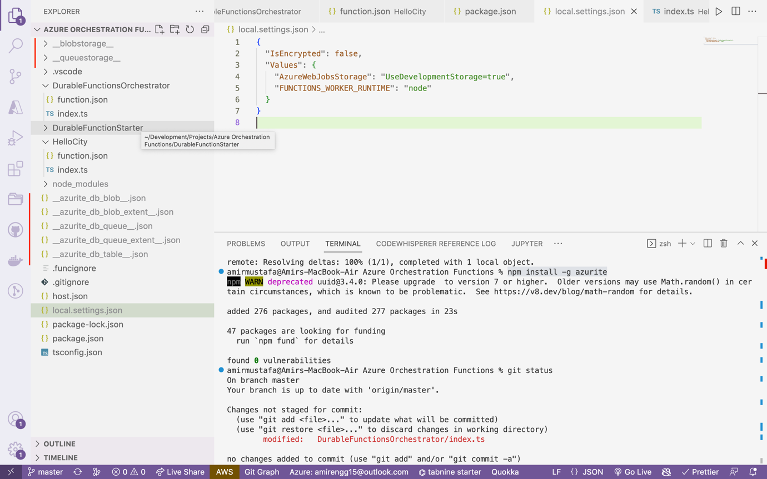

Way 2: Using Terminal:

Open terminal:

Start Azurite: azurite start

🡪 This command starts the three emulators - blob, table, queue storages

🡪 We observe three emulator servers running – blob, table, queue

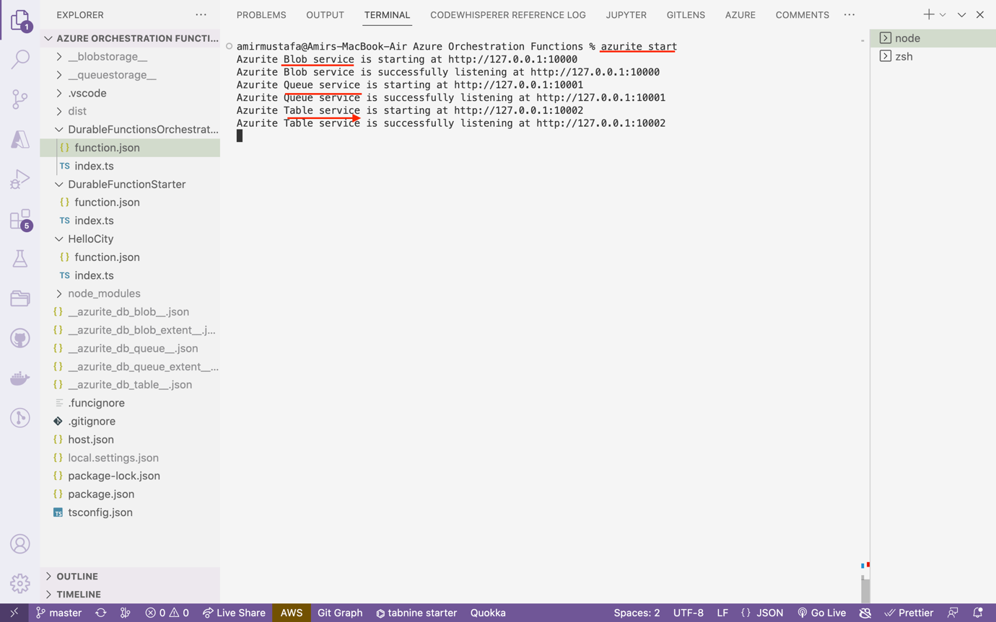

## Step 7: Setting up Storage Explorer with Azurite:

🡪 Install Storage Explorer software from Google – available Mac, Windows and Linux

### Download Link:

<https://azure.microsoft.com/en-us/products/storage/storage-explorer/>

🡪 Open Microsoft Storage Explorer:

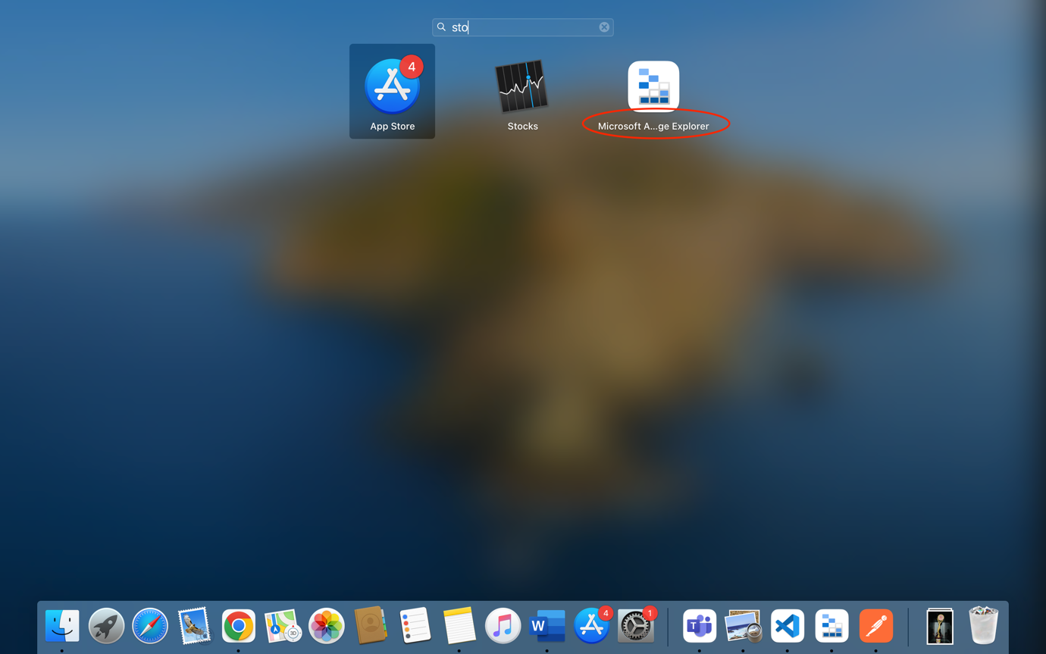

### Syncing with Azurite:

🡪 Click Connect button. Select Local emulator

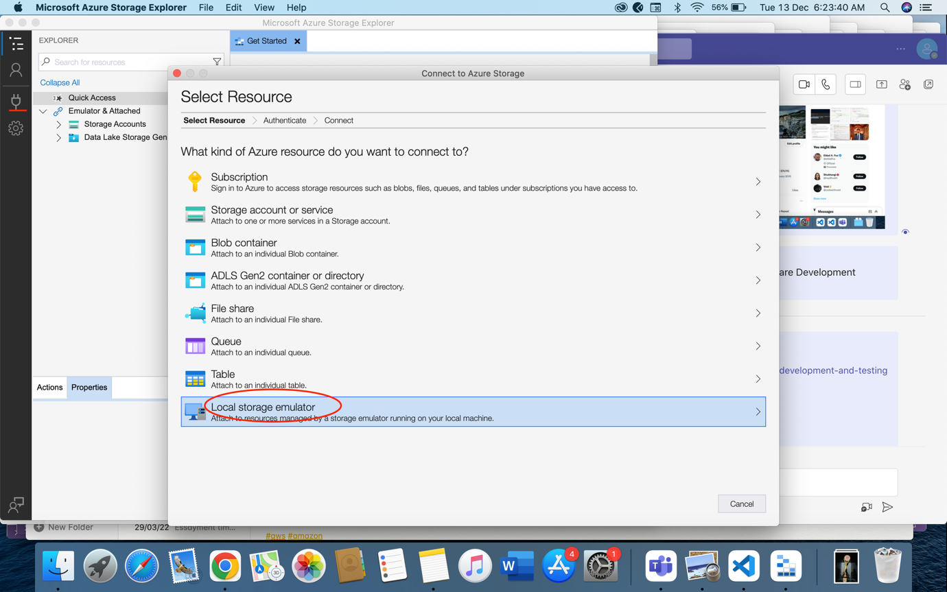

🡪 Click Next

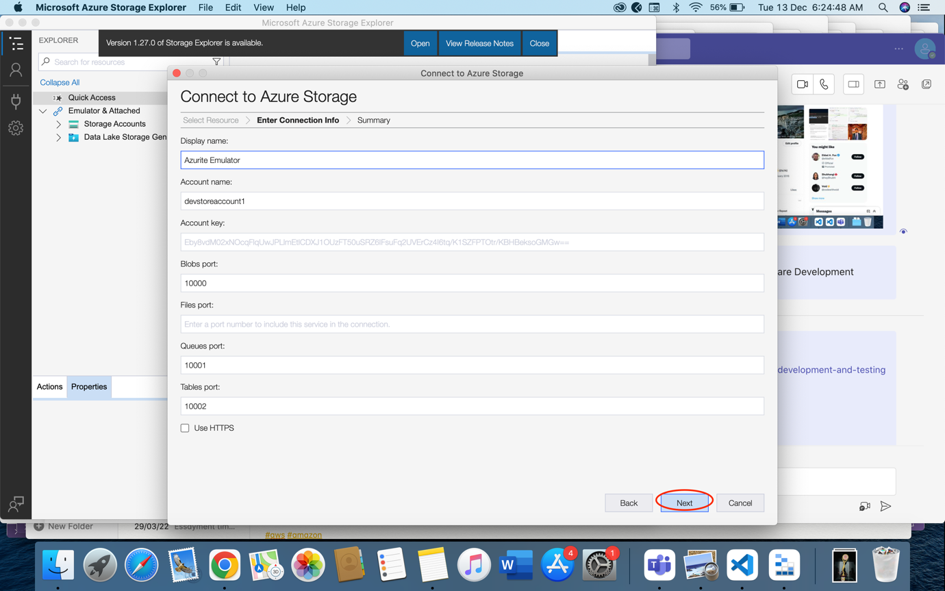

🡪 Copy somewhere three endpoints:

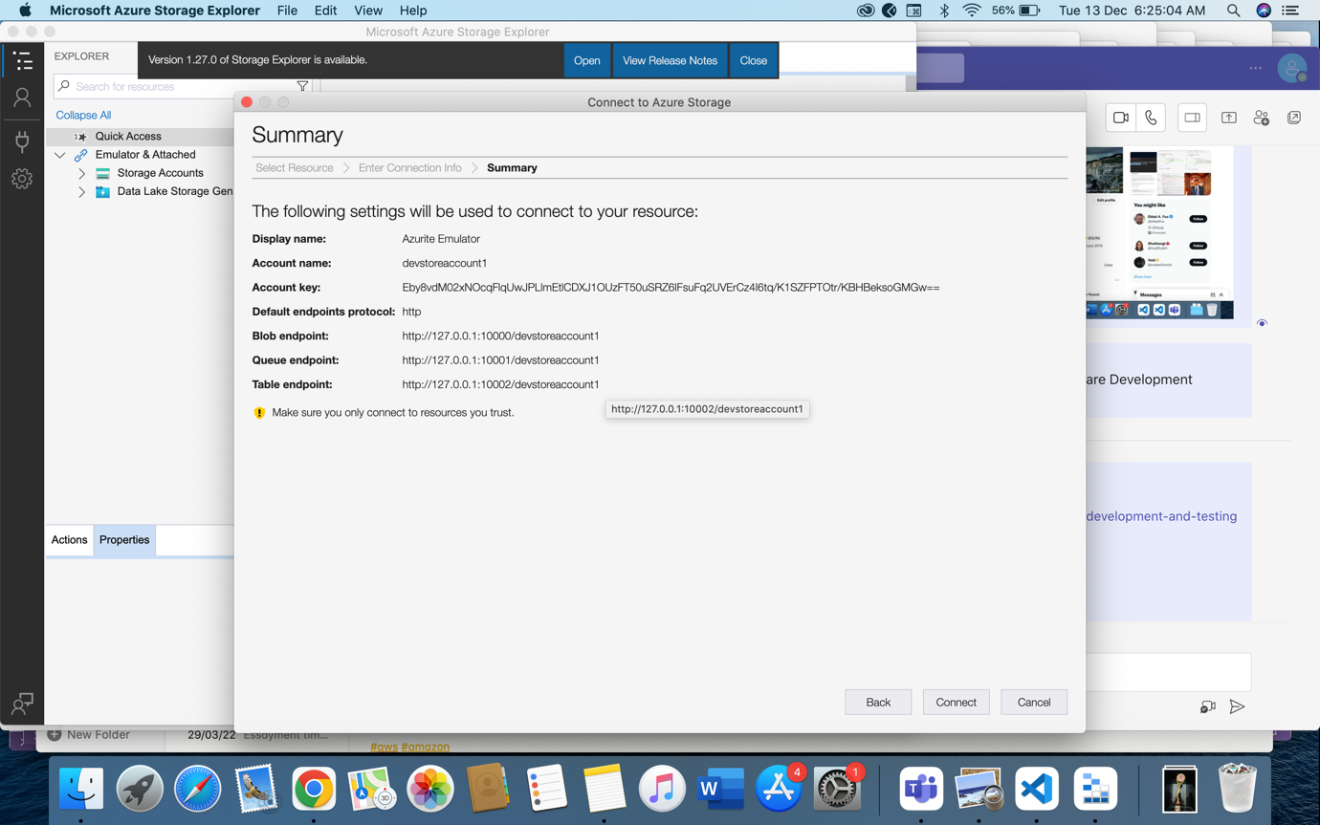

🡪 We observe our emulator is up and running:

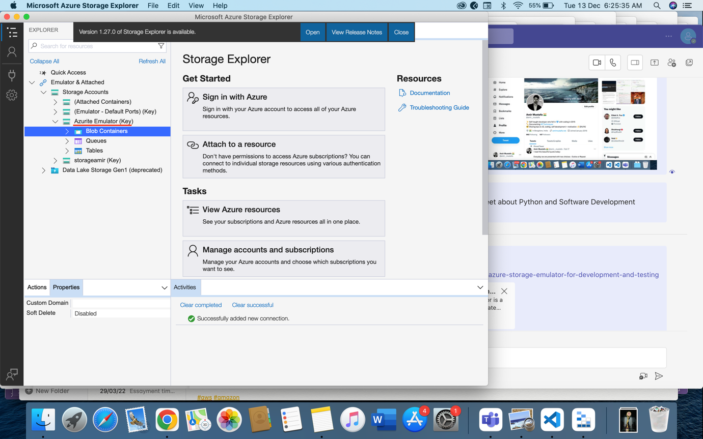

## Step 8: Starting Project:

Run: npm start

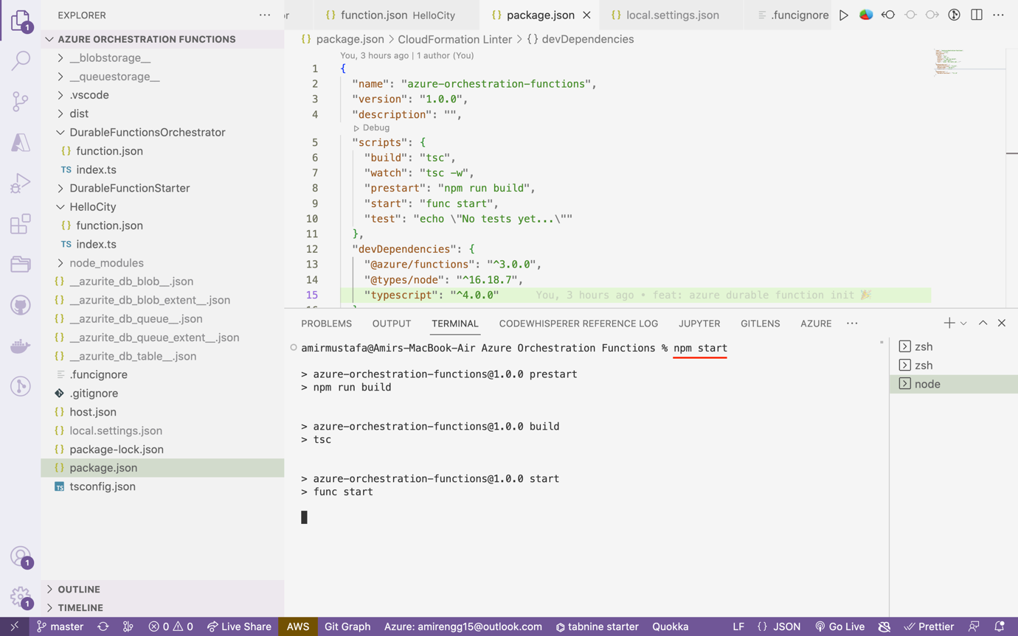

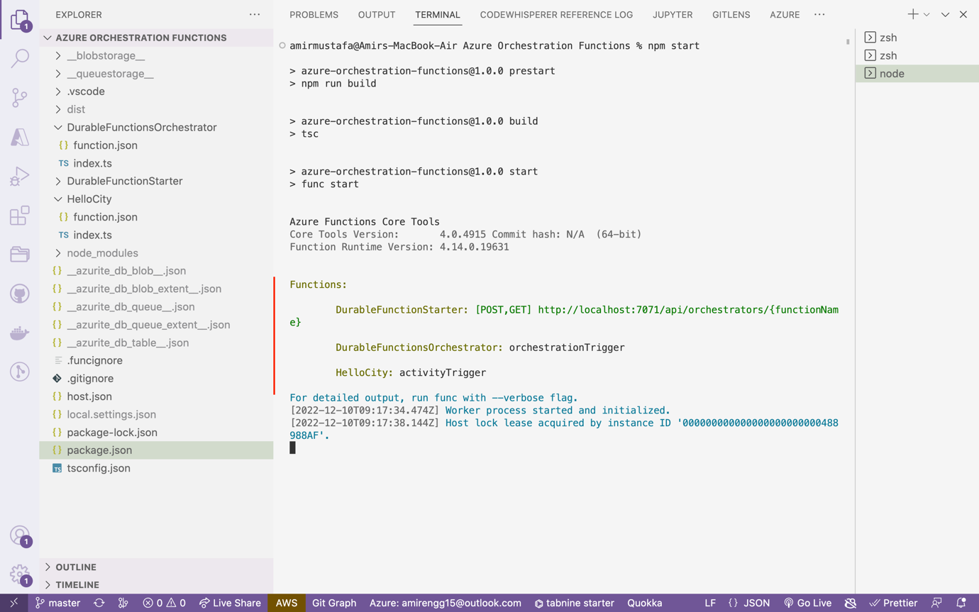

🡪 We observe our functions run –

1. DurableFunctionStarter (HTTP Trigger) - Running
2. DurableFunctionOrchestrator (Orchestrator Trigger) – Running
3. HelloCity (Activity Trigger) - Running

Time to hit our Orchetrator Function

## Step 9: Testing Postman API:

http://localhost:7071/api/orchestrators/DurableFunctionsOrchestrator

cURL:

curl --location --request GET 'http://localhost:7071/api/orchestrators/DurableFunctionsOrchestrator'

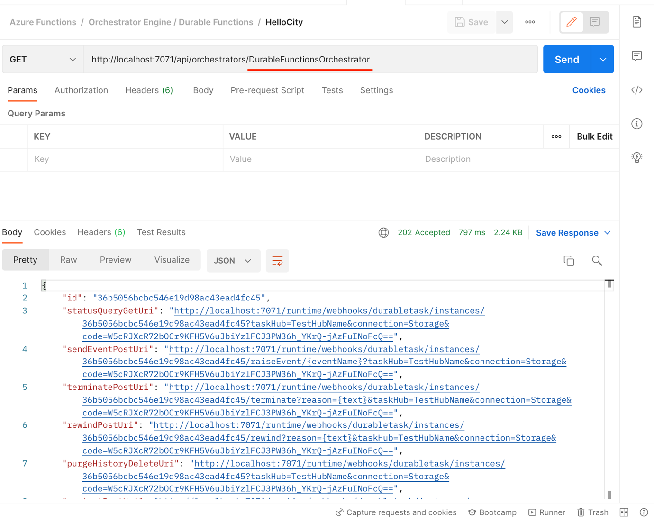

Response:

{

"id": "36b5056bcbc546e19d98ac43ead4fc45",

"statusQueryGetUri": "http://localhost:7071/runtime/webhooks/durabletask/instances/36b5056bcbc546e19d98ac43ead4fc45?taskHub=TestHubName&connection=Storage&code=W5cRJXcR72bOCr9KFH5V6uJbiYzlFCJ3PW36h_YKrQ-jAzFuINoFcQ==",

"sendEventPostUri": "http://localhost:7071/runtime/webhooks/durabletask/instances/36b5056bcbc546e19d98ac43ead4fc45/raiseEvent/{eventName}?taskHub=TestHubName&connection=Storage&code=W5cRJXcR72bOCr9KFH5V6uJbiYzlFCJ3PW36h_YKrQ-jAzFuINoFcQ==",

"terminatePostUri": "http://localhost:7071/runtime/webhooks/durabletask/instances/36b5056bcbc546e19d98ac43ead4fc45/terminate?reason={text}&taskHub=TestHubName&connection=Storage&code=W5cRJXcR72bOCr9KFH5V6uJbiYzlFCJ3PW36h_YKrQ-jAzFuINoFcQ==",

"rewindPostUri": "http://localhost:7071/runtime/webhooks/durabletask/instances/36b5056bcbc546e19d98ac43ead4fc45/rewind?reason={text}&taskHub=TestHubName&connection=Storage&code=W5cRJXcR72bOCr9KFH5V6uJbiYzlFCJ3PW36h_YKrQ-jAzFuINoFcQ==",

"purgeHistoryDeleteUri": "http://localhost:7071/runtime/webhooks/durabletask/instances/36b5056bcbc546e19d98ac43ead4fc45?taskHub=TestHubName&connection=Storage&code=W5cRJXcR72bOCr9KFH5V6uJbiYzlFCJ3PW36h_YKrQ-jAzFuINoFcQ==",

"restartPostUri": "http://localhost:7071/runtime/webhooks/durabletask/instances/36b5056bcbc546e19d98ac43ead4fc45/restart?taskHub=TestHubName&connection=Storage&code=W5cRJXcR72bOCr9KFH5V6uJbiYzlFCJ3PW36h_YKrQ-jAzFuINoFcQ==",

"suspendPostUri": "http://localhost:7071/runtime/webhooks/durabletask/instances/36b5056bcbc546e19d98ac43ead4fc45/suspend?reason={text}&taskHub=TestHubName&connection=Storage&code=W5cRJXcR72bOCr9KFH5V6uJbiYzlFCJ3PW36h_YKrQ-jAzFuINoFcQ==",

"resumePostUri": "http://localhost:7071/runtime/webhooks/durabletask/instances/36b5056bcbc546e19d98ac43ead4fc45/resume?reason={text}&taskHub=TestHubName&connection=Storage&code=W5cRJXcR72bOCr9KFH5V6uJbiYzlFCJ3PW36h_YKrQ-jAzFuINoFcQ=="

}

🡪 From above API, we are interested in first key:

statusQueryURI:

Click this and hit below URL:

http://localhost:7071/runtime/webhooks/durabletask/instances/36b5056bcbc546e19d98ac43ead4fc45?taskHub=TestHubName&connection=Storage&code=W5cRJXcR72bOCr9KFH5V6uJbiYzlFCJ3PW36h_YKrQ-jAzFuINoFcQ==

cURL:

curl --location --request GET 'http://localhost:7071/runtime/webhooks/durabletask/instances/36b5056bcbc546e19d98ac43ead4fc45?taskHub=TestHubName&connection=Storage&code=W5cRJXcR72bOCr9KFH5V6uJbiYzlFCJ3PW36h_YKrQ-jAzFuINoFcQ=='

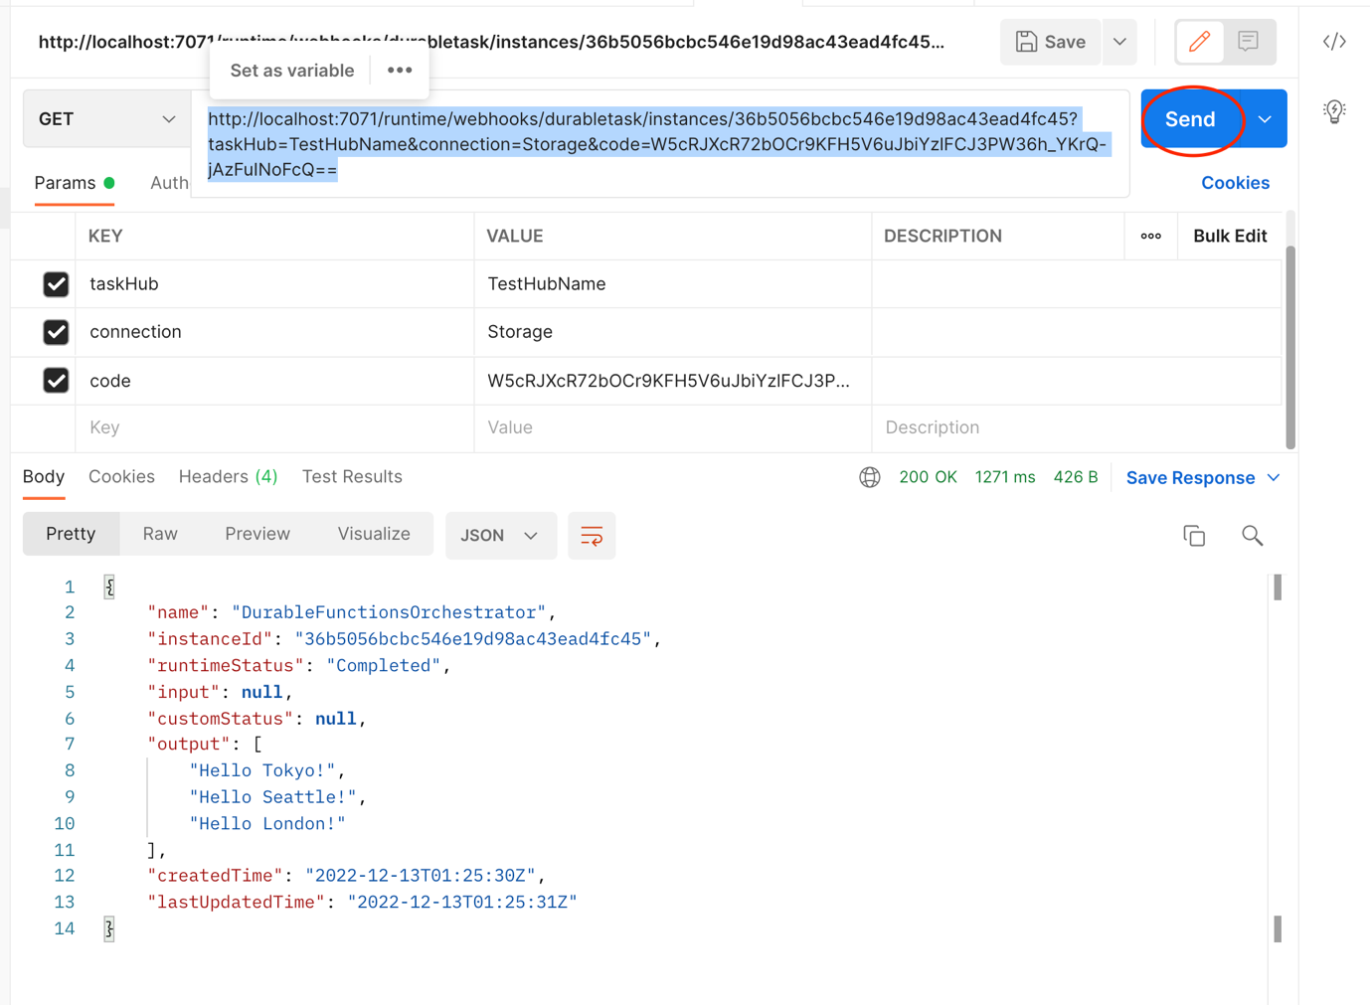

🡪 We get response from the below code:

i.e. DurableFunctionsOrchestrator/index.ts

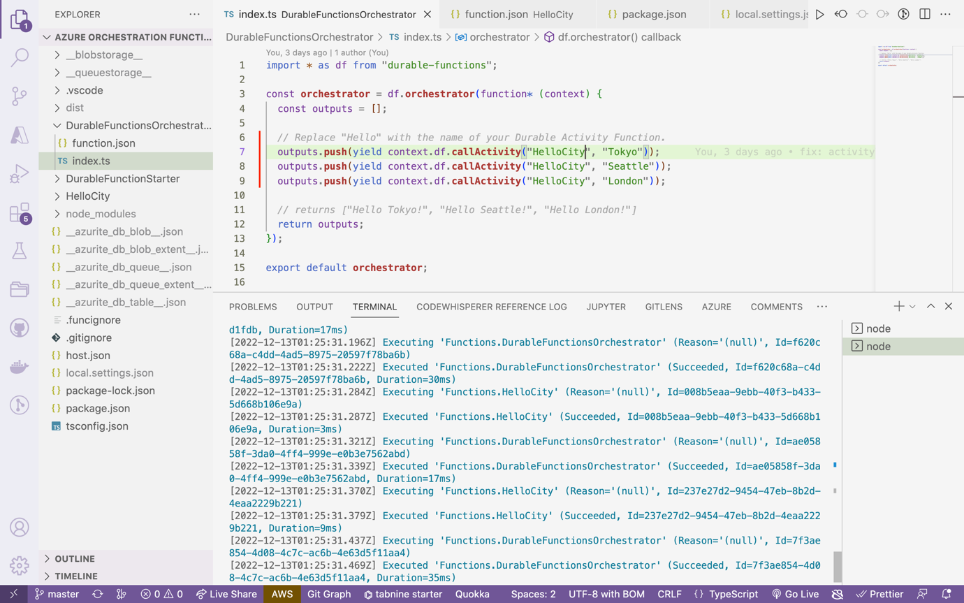

## Step 10: Observation in Storage Account:

🡪 If now we go to the storage account after hitting the above API. We observe there are two table created:

**TestHubNameInstances** and **TestHubNameHistory**

### TestHubNameInstance:

**🡪**Number of times this function is hit

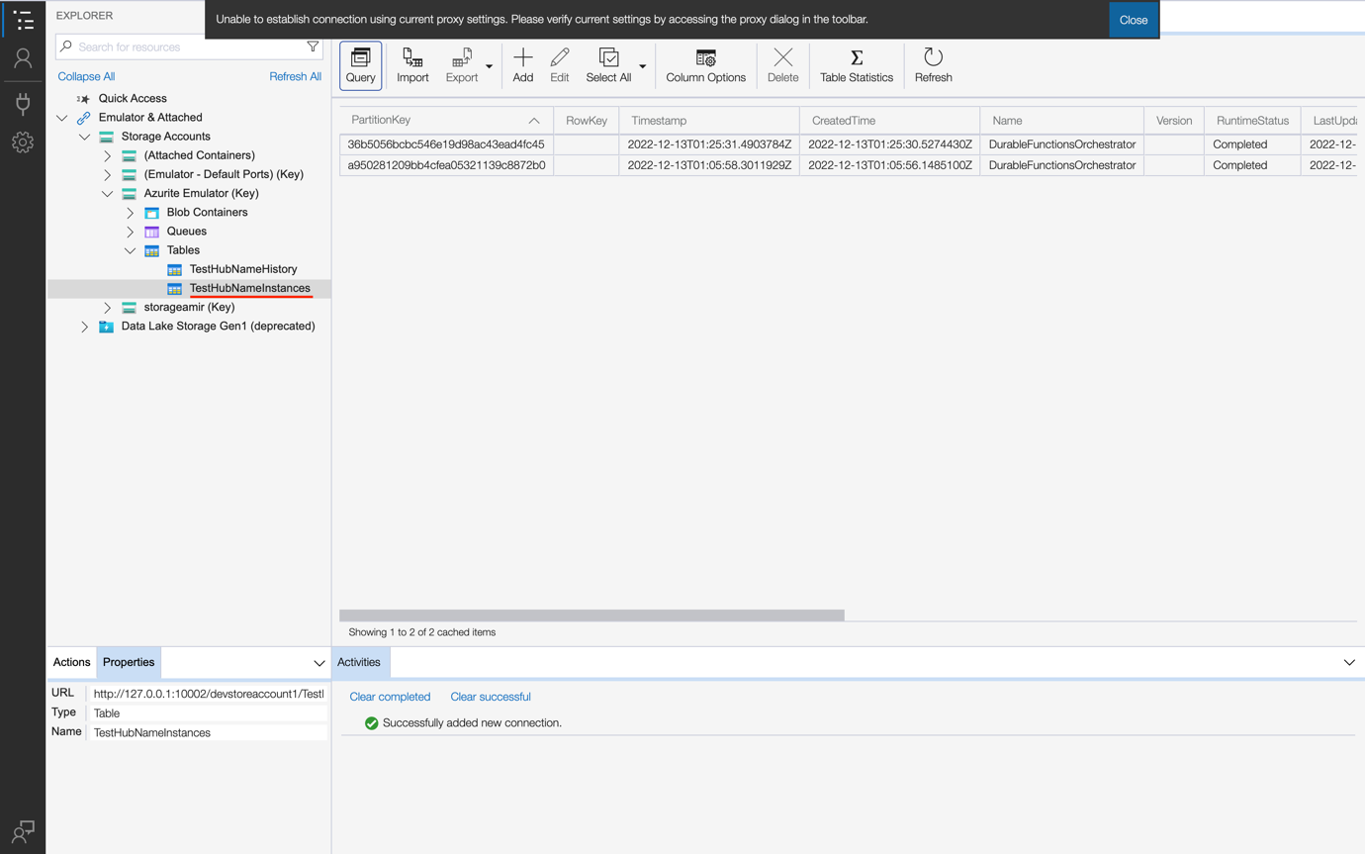

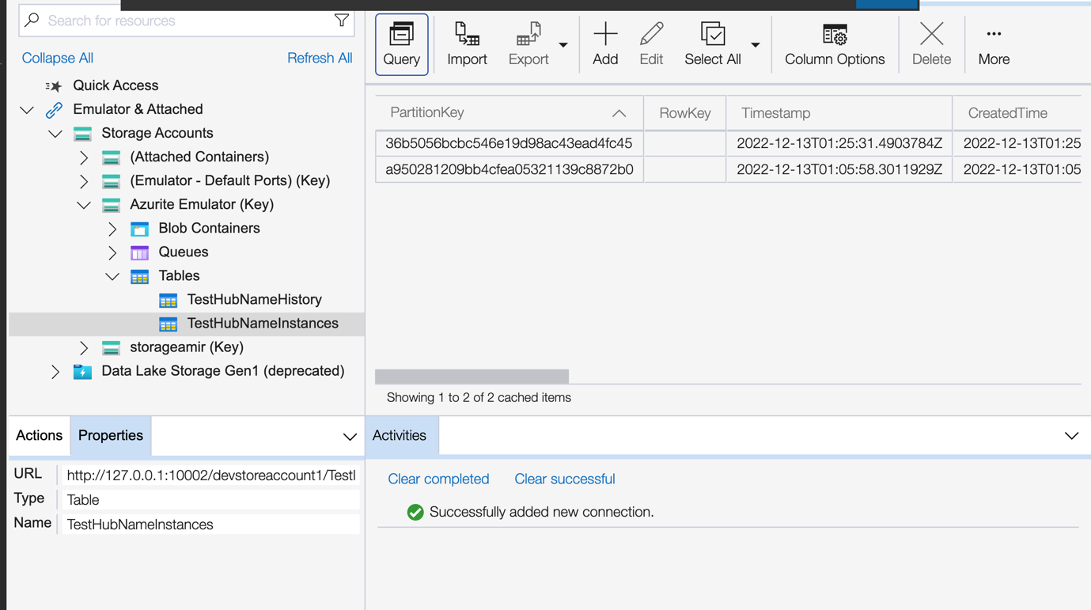

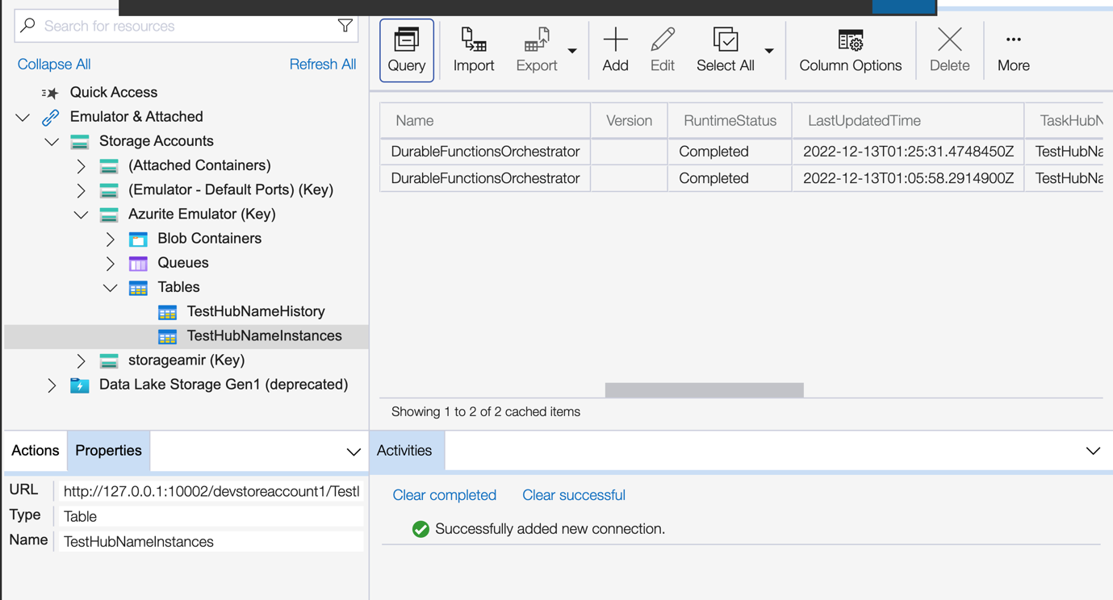

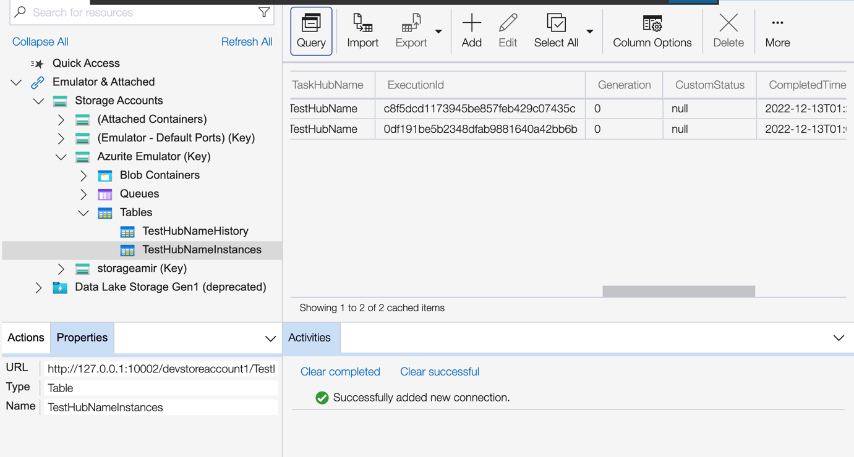

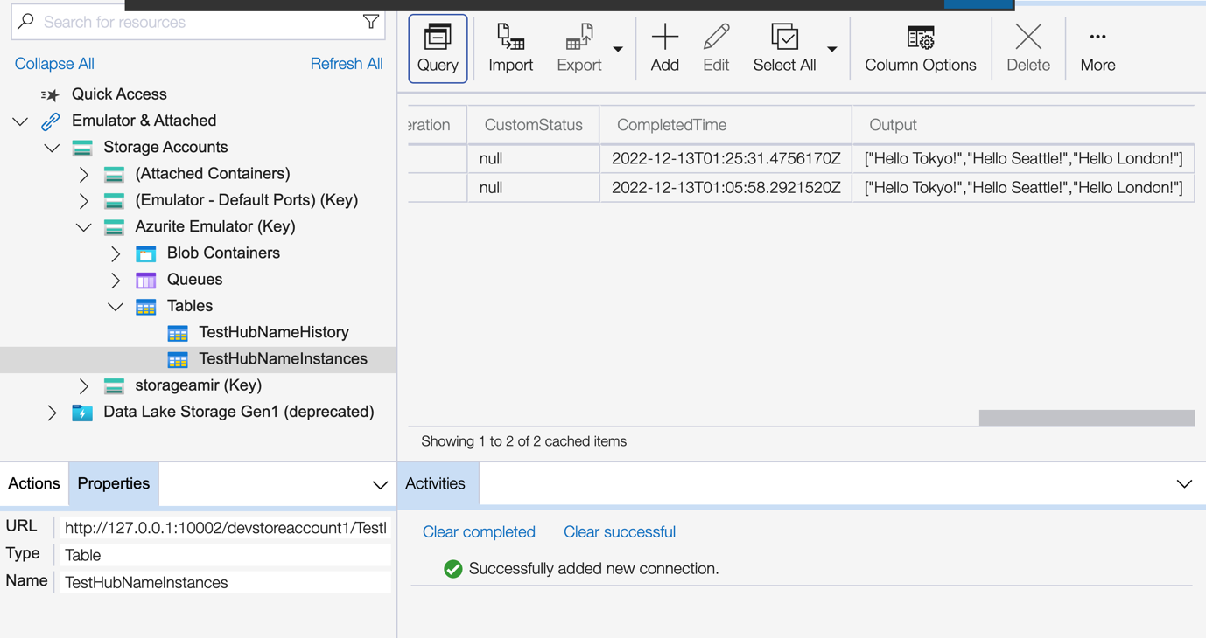

### TestHubNameHistory:

🡪 Here basically we see mechanics of Orchestration, order in which executed and result

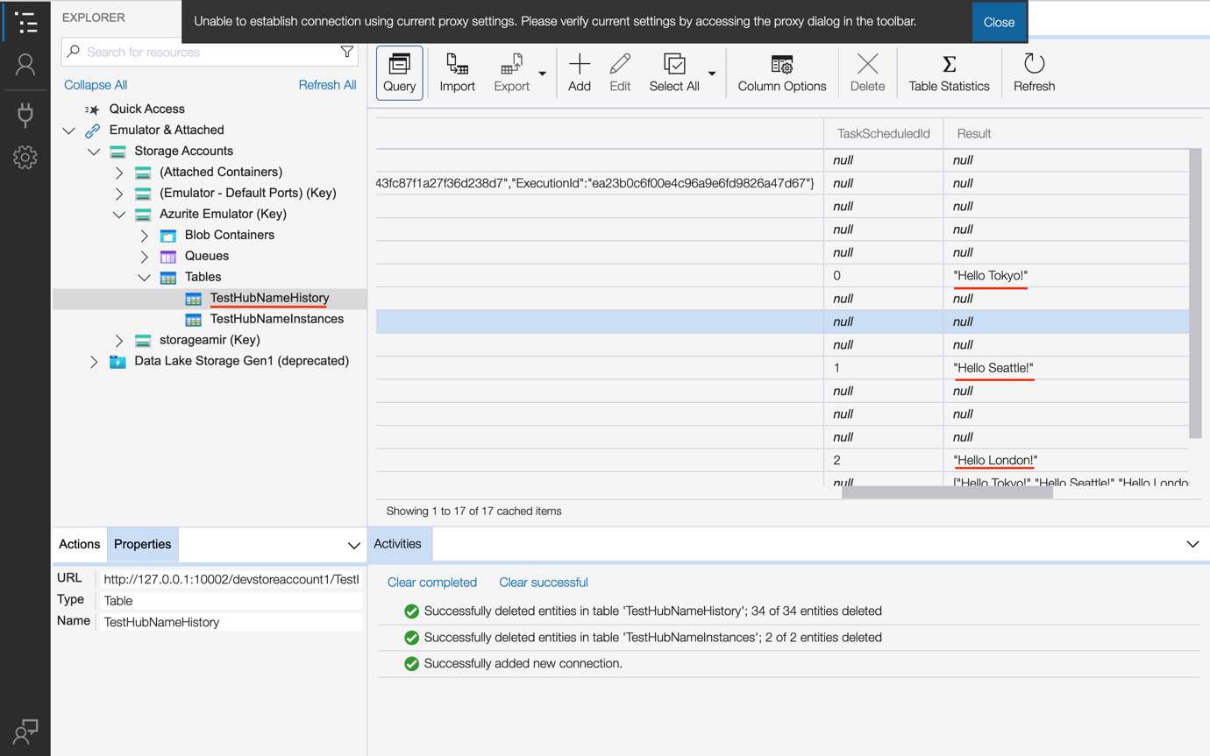

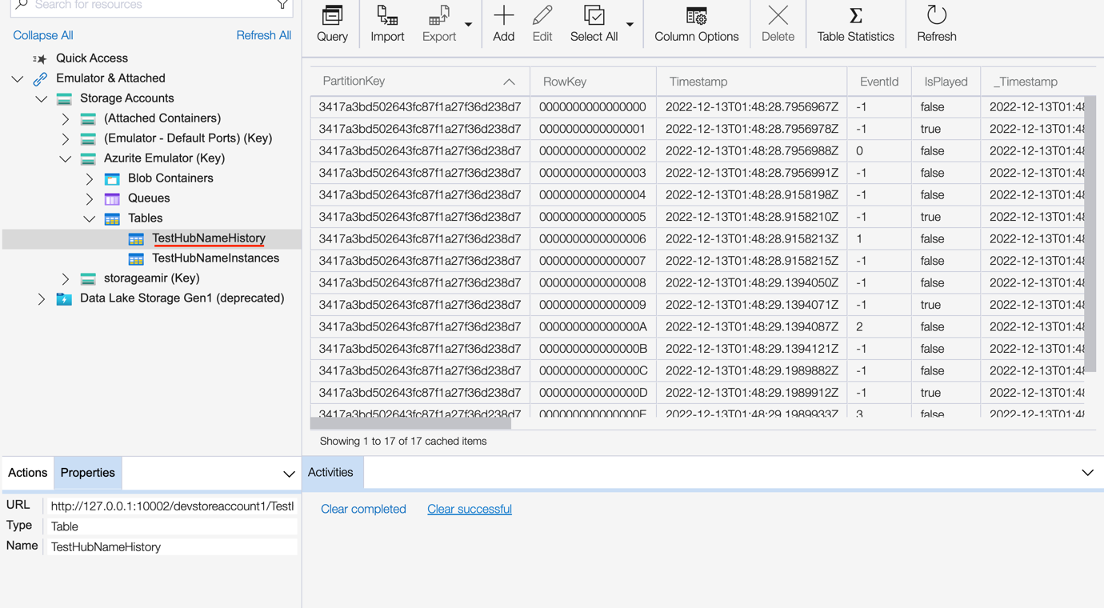

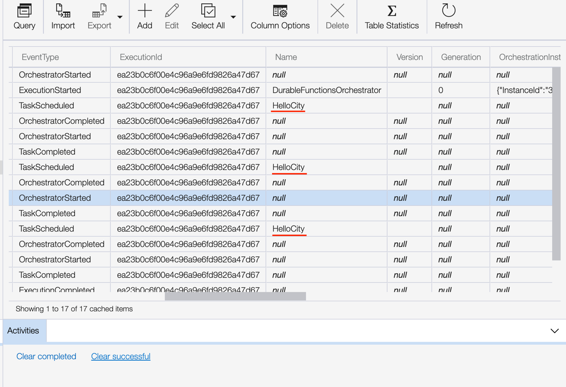

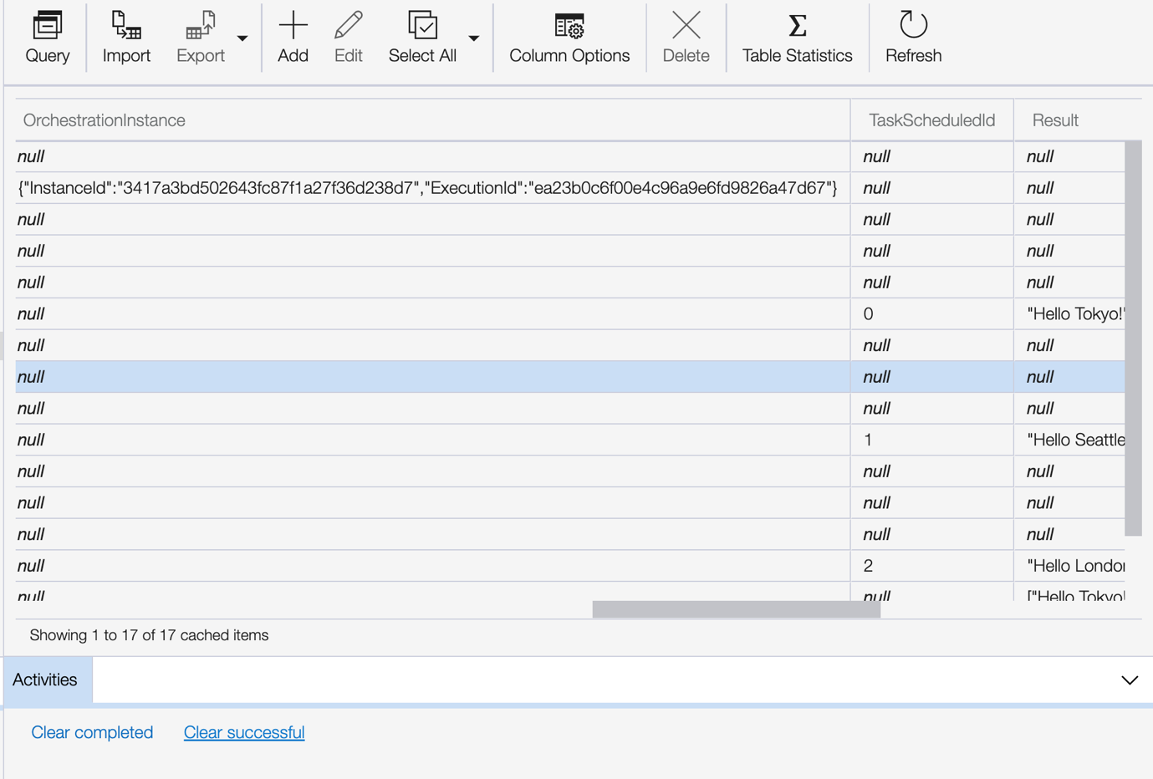

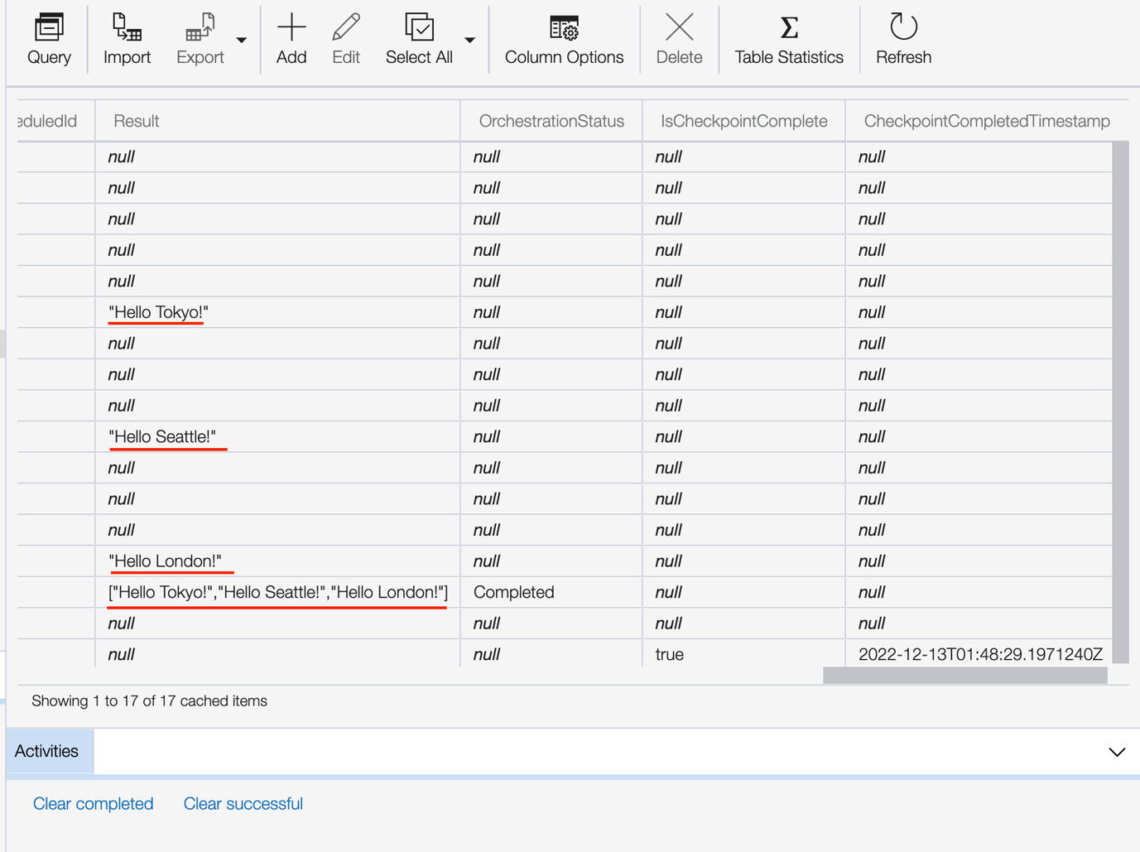

**🡪** We also get in the console some basic loggings:

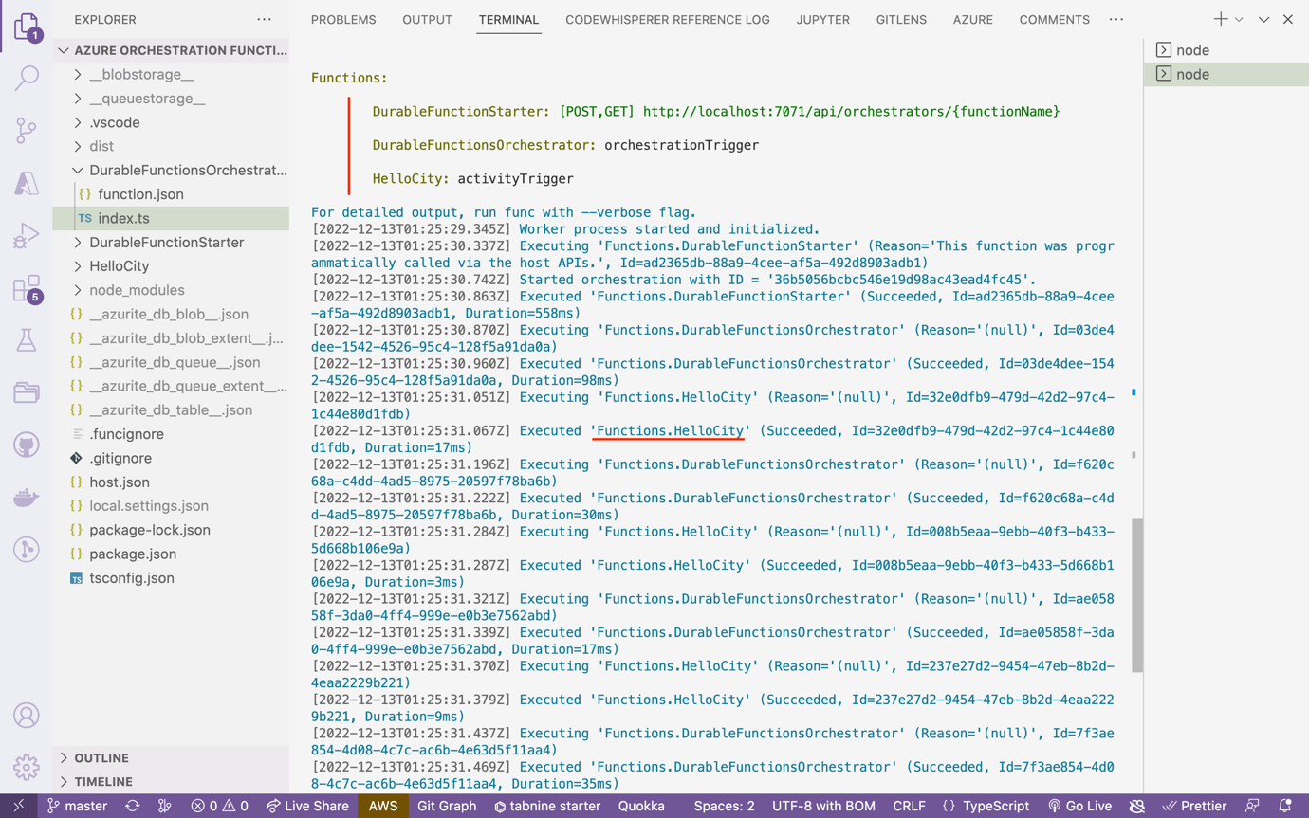

# 4. Eg2: Realtime Implementation of OE:

## Goal of this API:

STEP 1: Get user information of GitHub repository containing user ID (i.e. github username)

STEP 2: Based on user ID we will fetch additional information of the Github user

🡪 We will re-use the client function

## Create Orchestrator:

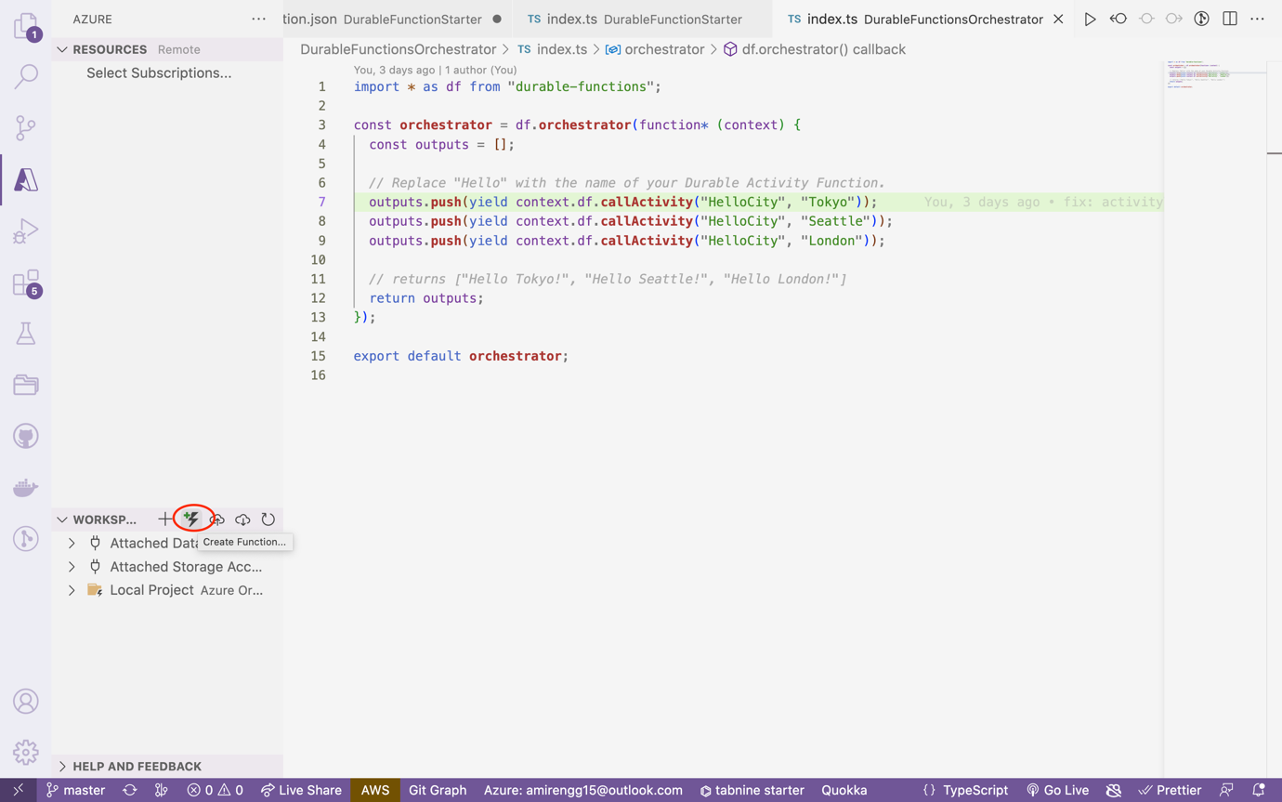

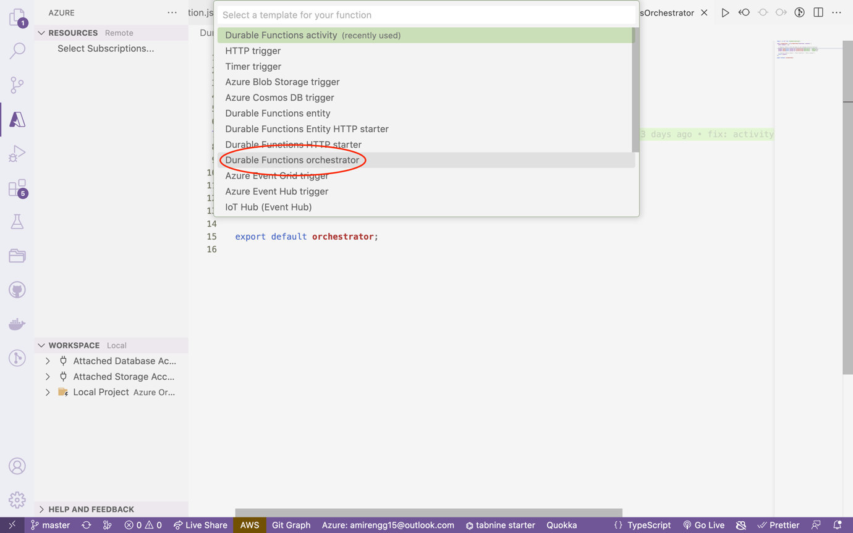

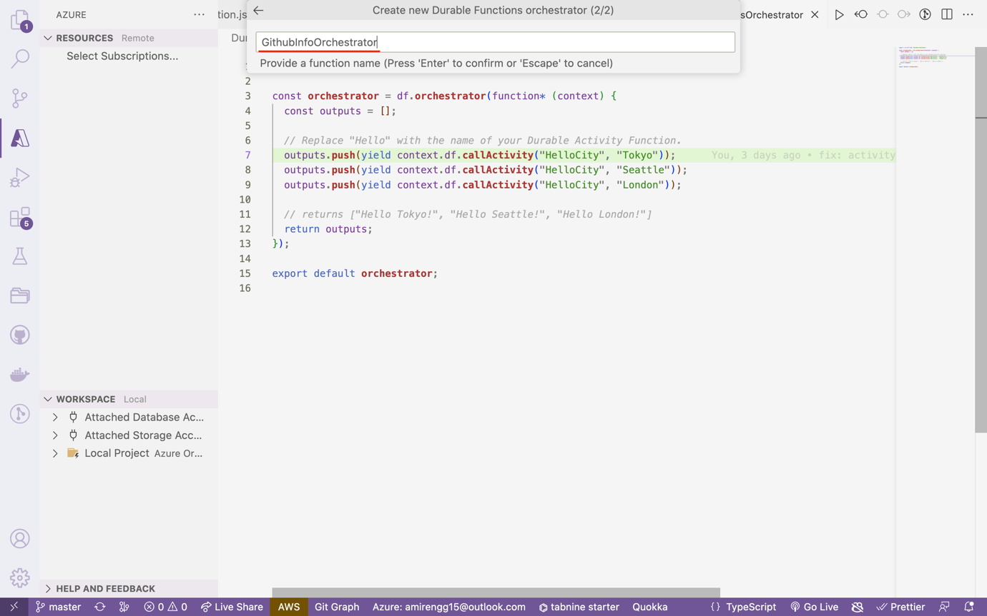

## Creating two activity triggers:

### GetRepositoryByName:

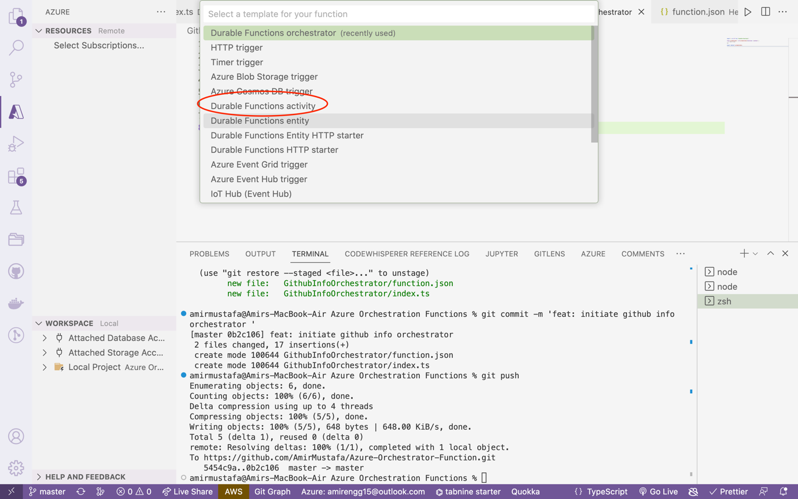

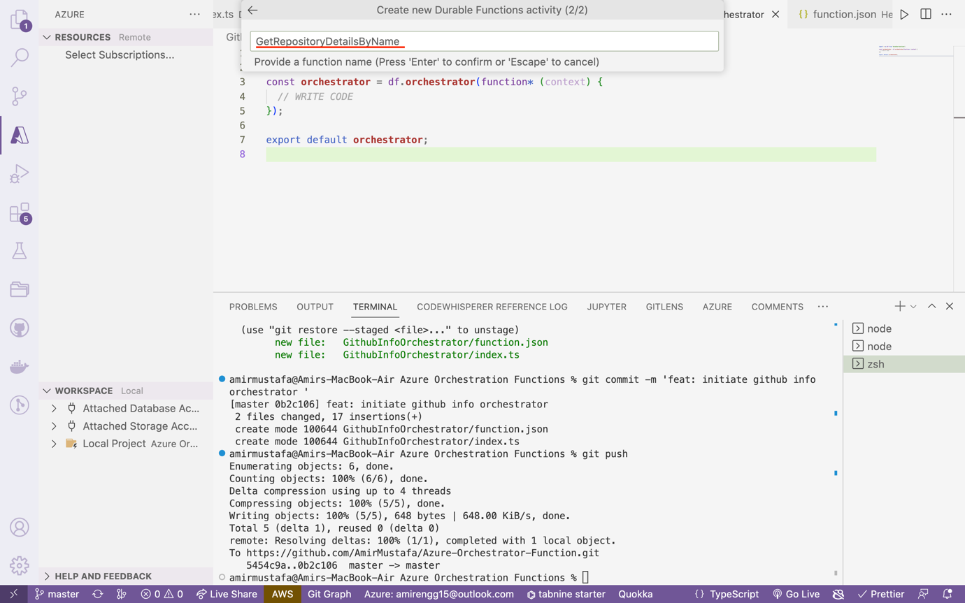

Commit: <https://github.com/AmirMustafa/Azure-Orchestrator-Function/commit/139b80f0b376e1f67ad3c108d893c7228857b3d8>

### GetUserNameByID:

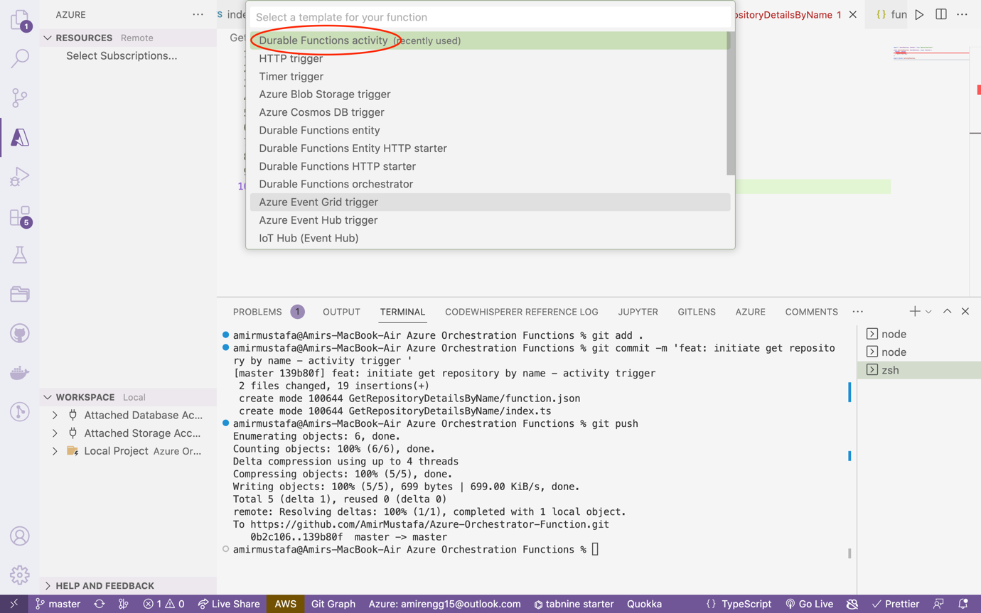

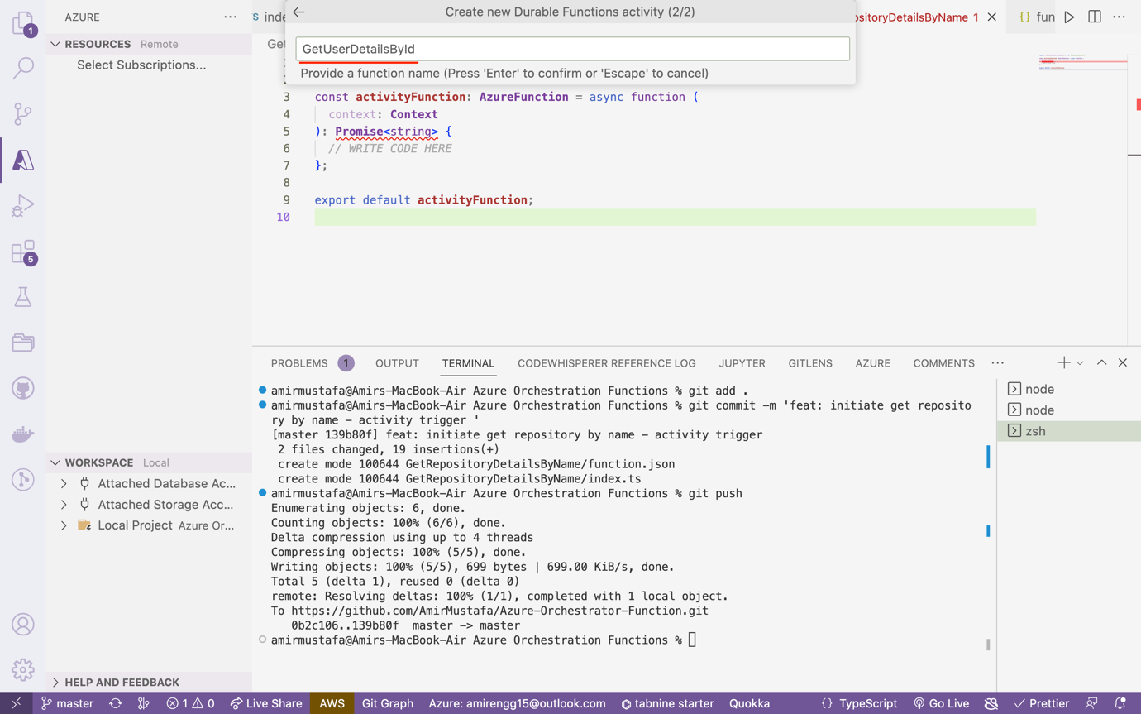

Commit: <https://github.com/AmirMustafa/Azure-Orchestrator-Function/commit/a5a7c9ef46ea0100a9cae8784f2231c78e293f05>

## Octokit:

🡪 There is an SDK to fetch Github details:

<https://www.npmjs.com/package/@octokit/core>

npm i @octokit/core

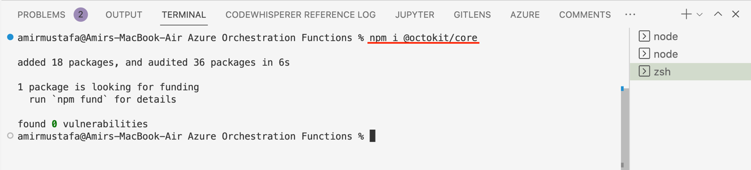

🡪 So basically till now basic rules are written. Now we have to write orchestration rules:

## Path: GithubInfoOrchestrator/index.ts

import * as df from "durable-functions";

const **orchestrator** = df.**orchestrator**(function* (context) {

const userId: string = yield context.df.**callActivity**(

"GetRepositoryDetailsByName",

context.bindingData.input

);

*// Chaining response from first actitity trigger to next actitity*

context.bindingData.input.userId = userId;

const userInfo = yield context.df.**callActivity**(

"GetUserDetailsById",

context.bindingData.input

);

return userInfo;

});

export default **orchestrator**;

🡪 context.bindingData.input in second parameter first comes from client function

🡪 First we will invoke first activity trigger – **GetRepositoryDetailsByName**.

🡪 Response should give user ID

🡪 We will feed response in the context.binding.input that will be served into next activity trigger – **GetUserDetailsById**

**1st Activity Trigger:**

## Path: GetRepositoryDetailsByName/index.ts

import { AzureFunction, Context } from "@azure/functions";

import { Octokit } from "@octokit/core";

const **activityFunction**: **AzureFunction** = async function (

context: **Context**

): **Promise**<string> {

const octokit = new **Octokit**();

const query = `${context.bindingData.repositoryName.**toString**()} in:name`;

const searhResult = await octokit.**request**("GET /search/repositories", {

q: query,

});

const exactMatch = searhResult.data.items.**find**(

(item) => item.name === context.bindingData.repositoryName.**toString**()

);

return exactMatch.owner.login;

};

export default **activityFunction**;

🡪 Above code basically accepts repository from body of postman and fetch user ID of the respository

**2nd Activity Trigger:**

## Path: GetUserDetailsById/index.ts

import { AzureFunction, Context } from "@azure/functions";

import { Octokit } from "@octokit/core";

const **activityFunction**: **AzureFunction** = async function (

context: **Context**

): **Promise**<any> {

// LOGIC OF THIS ACTIVITY TRIGGER

const octokit = new **Octokit**();

const apiPath = `/users/${context.bindingData. userId.**toString**()}`;

const searchResult = await octokit.**request**(apiPath);

const userData = <**JSON**>searchResult.data;

return userData;

};

export default **activityFunction**;

🡪 Based on the user ID above code will fetch Github user details

🡪 Let us restart the Azure function terminal

npm start

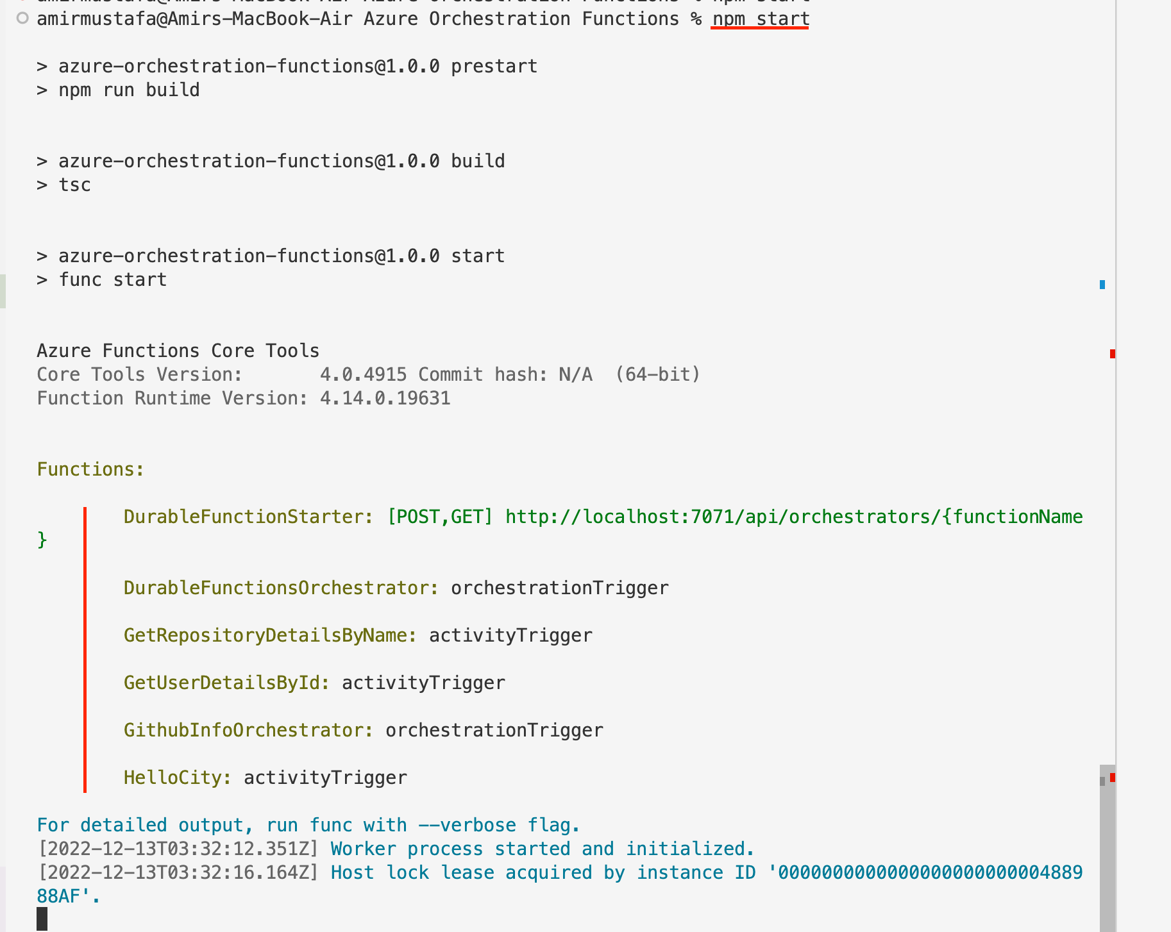

## Testing Postman API:

🡪 Let hit the API from postman:

cURL:

curl --location --request GET 'http://localhost:7071/api/orchestrators/GithubInfoOrchestrator' \

--header 'Content-Type: application/json' \

--data-raw '{

"repositoryName": "Azure-Orchestrator-Function"

}'

API: http://localhost:7071/api/orchestrators/GithubInfoOrchestrator

Type: GET

Body:

{

"repositoryName": "Azure-Orchestrator-Function"

}

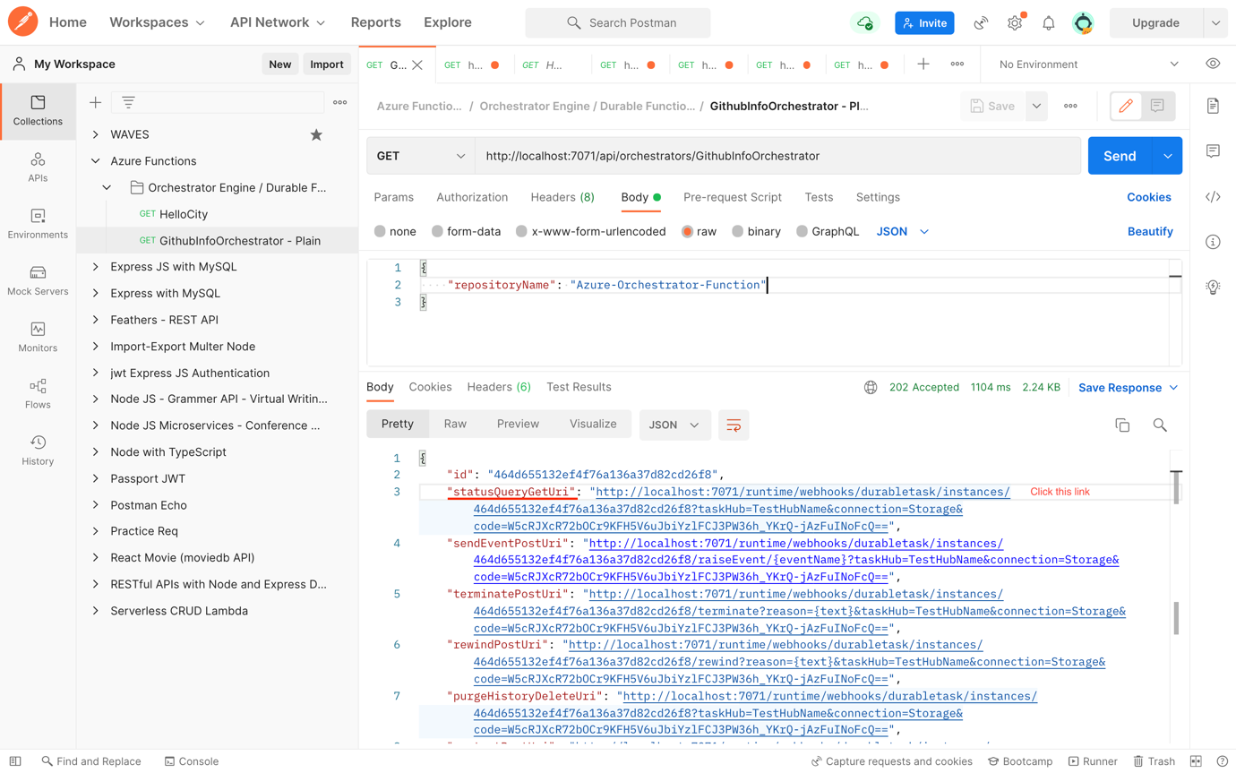

🡪 Click Send, we observe user details of this repository is coming.

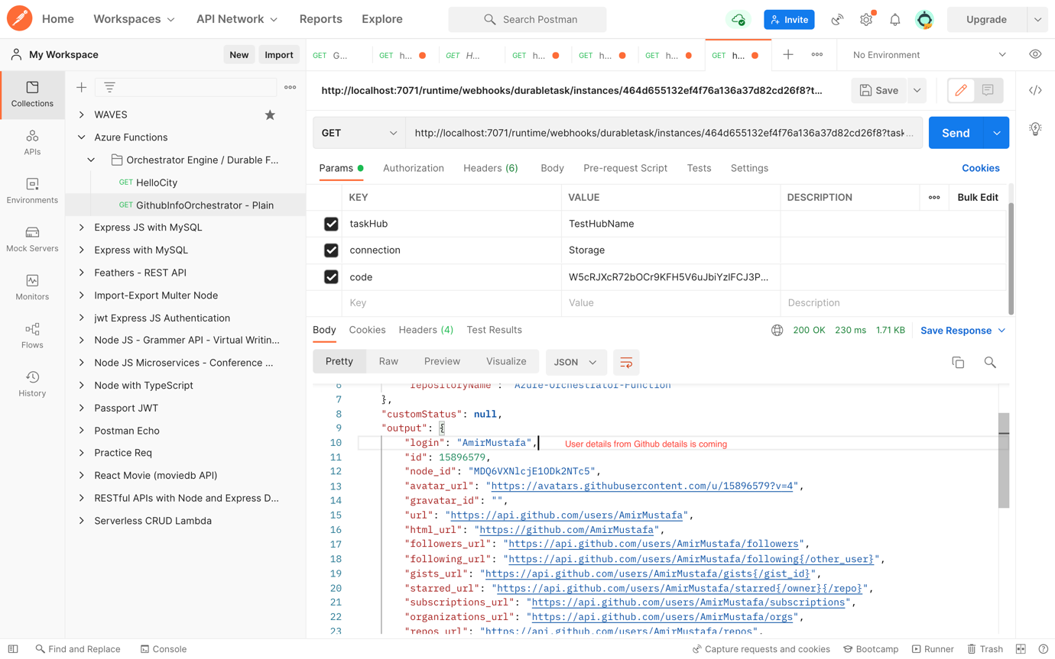

Output Response:

{

"name": "GithubInfoOrchestrator",

"instanceId": "464d655132ef4f76a136a37d82cd26f8",

"runtimeStatus": "Completed",

"input": {

"repositoryName": "Azure-Orchestrator-Function"

},

"customStatus": **null**,

"output": {

"login": "AmirMustafa",

"id": 15896579,

"node_id": "MDQ6VXNlcjE1ODk2NTc5",

"avatar_url": "https://avatars.githubusercontent.com/u/15896579?v=4",

"gravatar_id": "",

"url": "https://api.github.com/users/AmirMustafa",

"html_url": "https://github.com/AmirMustafa",

"followers_url": "https://api.github.com/users/AmirMustafa/followers",

"following_url": "https://api.github.com/users/AmirMustafa/following{/other_user}",

"gists_url": "https://api.github.com/users/AmirMustafa/gists{/gist_id}",

"starred_url": "https://api.github.com/users/AmirMustafa/starred{/owner}{/repo}",

"subscriptions_url": "https://api.github.com/users/AmirMustafa/subscriptions",

"organizations_url": "https://api.github.com/users/AmirMustafa/orgs",

"repos_url": "https://api.github.com/users/AmirMustafa/repos",

"events_url": "https://api.github.com/users/AmirMustafa/events{/privacy}",

"received_events_url": "https://api.github.com/users/AmirMustafa/received_events",

"type": "User",

"site_admin": **false**,

"name": "Amir Mustafa",

"company": "Ernst and Young (EY) | Ex-TCS, Xebia",

"blog": "http://amirmustafa.net/",

"location": "Bangalore, India",

"email": **null**,

"hireable": **true**,

"bio": "Developer, Consultant, and Technology Enthusiast",

"twitter_username": "amir__mustafa",

"public_repos": 117,

"public_gists": 0,

"followers": 23,

"following": 9,

"created_at": "2015-11-17T20:04:40Z",

"updated_at": "2022-10-17T06:37:27Z"

},

"createdTime": "2022-12-17T06:11:51Z",

"lastUpdatedTime": "2022-12-17T06:11:53Z"

}

# 5. Retry in Orchestration Engine (OE):

🡪 This is used to handle error cases in Orchestration Engine.

🡪 So what happens if API request hit fails (eg. Github API busy, overload and somehow fails).

🡪 For this OE has feature to retry after some intervals of time. Let us now implement in code

## GetRepositoryDetailsById (Orchestration trigger)

Path: GetRepositoryDetailsById/index.ts

import * as df from "durable-functions";

const **orchestrator** = df.**orchestrator**(function* (context) {

const firstRetryIntervalInMilliseconds: number = 1000;

const maxNumberOfAttempts: number = 3;

const maxRetryIntervalInSeconds: number = 1000;

const retryTimeoutInMilliseconds: number = 7000;

const retryConfig: **df**.**RetryOptions** = new df.**RetryOptions**(

firstRetryIntervalInMilliseconds,

maxNumberOfAttempts

);

retryConfig.maxRetryIntervalInMilliseconds = maxRetryIntervalInSeconds;

retryConfig.retryTimeoutInMilliseconds = retryTimeoutInMilliseconds;

const userId: string = yield context.df.**callActivityWithRetry**(

"GetRepositoryDetailsByName",

retryConfig,

context.bindingData.input

);

*// Chaining response from first actitity trigger to next actitity*

context.bindingData.input.userId = userId;

*// context.log("OE ==>", userId, context.bindingData.input);*

const userInfo = yield context.df.**callActivityWithRetry**(

"GetUserDetailsById",

retryConfig,

context.bindingData.input

);

return userInfo;

});

export default **orchestrator**;

🡪 Basically we have retry configuration object with some parameters:

**firstRetryIntervalInMilliseconds –** first retry time in milliseconds

**maxNumberOfAttempts –** number of retries

**maxRetryIntervalInSeconds –** retry interval in milliseconds

**retryTimeoutInMilliseconds –** timeout for retry

Previously we called:

callActivity(‘<activity-trigger-function-name>’, context.binding)

Now we will call

callActivityWithRetry(‘<activity-trigger-function-name>’, retryConfig, context.binding)

Commit: <https://github.com/AmirMustafa/Azure-Orchestrator-Function/commit/2767da8bc6e4dded1a6efecd821819ba88c1cad7>

# 6. Testing Retry Functionality:

🡪 Now to test retry functionality for dev let us generate error by trick. In real scenarios some API failure will happen

## GetRepositoryDetailsByName (Activity trigger)

**Path: GetRepositoryDetailsByName/index.ts**

**🡪** We will basically pass one flag from Postman body

import { AzureFunction, Context } from "@azure/functions";

import { Octokit } from "@octokit/core";

const **activityFunction**: **AzureFunction** = async function (

context: **Context**

): **Promise**<string> {

// Added below logic to test error scenario – manually. In real scenario API might fail due to any reason.

if (

context.bindingData.raiseException &&

context.bindingData.raiseException === true

) {

context.**log**("Error enforced by caller");

throw {

name: "ForcedException",

message: "Caller enforced exception",

**toString**: function () {

return this.name + ": " + this.message;

},

};

}

const octokit = new **Octokit**();

const query = `${context.bindingData.repositoryName.**toString**()} in:name`;

const searhResult = await octokit.**request**("GET /search/repositories", {

q: query,

});

context.**log**(

"respository name ===> ",

context.bindingData.repositoryName,

context.bindingData

);

context.bindingData.repositoryName = context.bindingData.repositoryName;

context.**log**("search data ==>", searhResult);

const exactMatch = searhResult.data.items.**find**(

(item) => item.name === context.bindingData.repositoryName.**toString**()

);

context.**log**("exactMatch ==>", exactMatch);

context.bindingData.repositoryName = context.bindingData.repositoryName;

return exactMatch.owner.login;

};

export default **activityFunction**;

## Testing in Postman API:

http://localhost:7071/api/orchestrators/GithubInfoOrchestrator

cURL:

curl --location --request GET 'http://localhost:7071/api/orchestrators/GithubInfoOrchestrator' \

--header 'Content-Type: application/json' \

--data-raw '{

"repositoryName": "Azure-Orchestrator-Function",

"raiseException": "true"

}'

Body:

{

"repositoryName": "Azure-Orchestrator-Function",

"raiseException": "true"

}

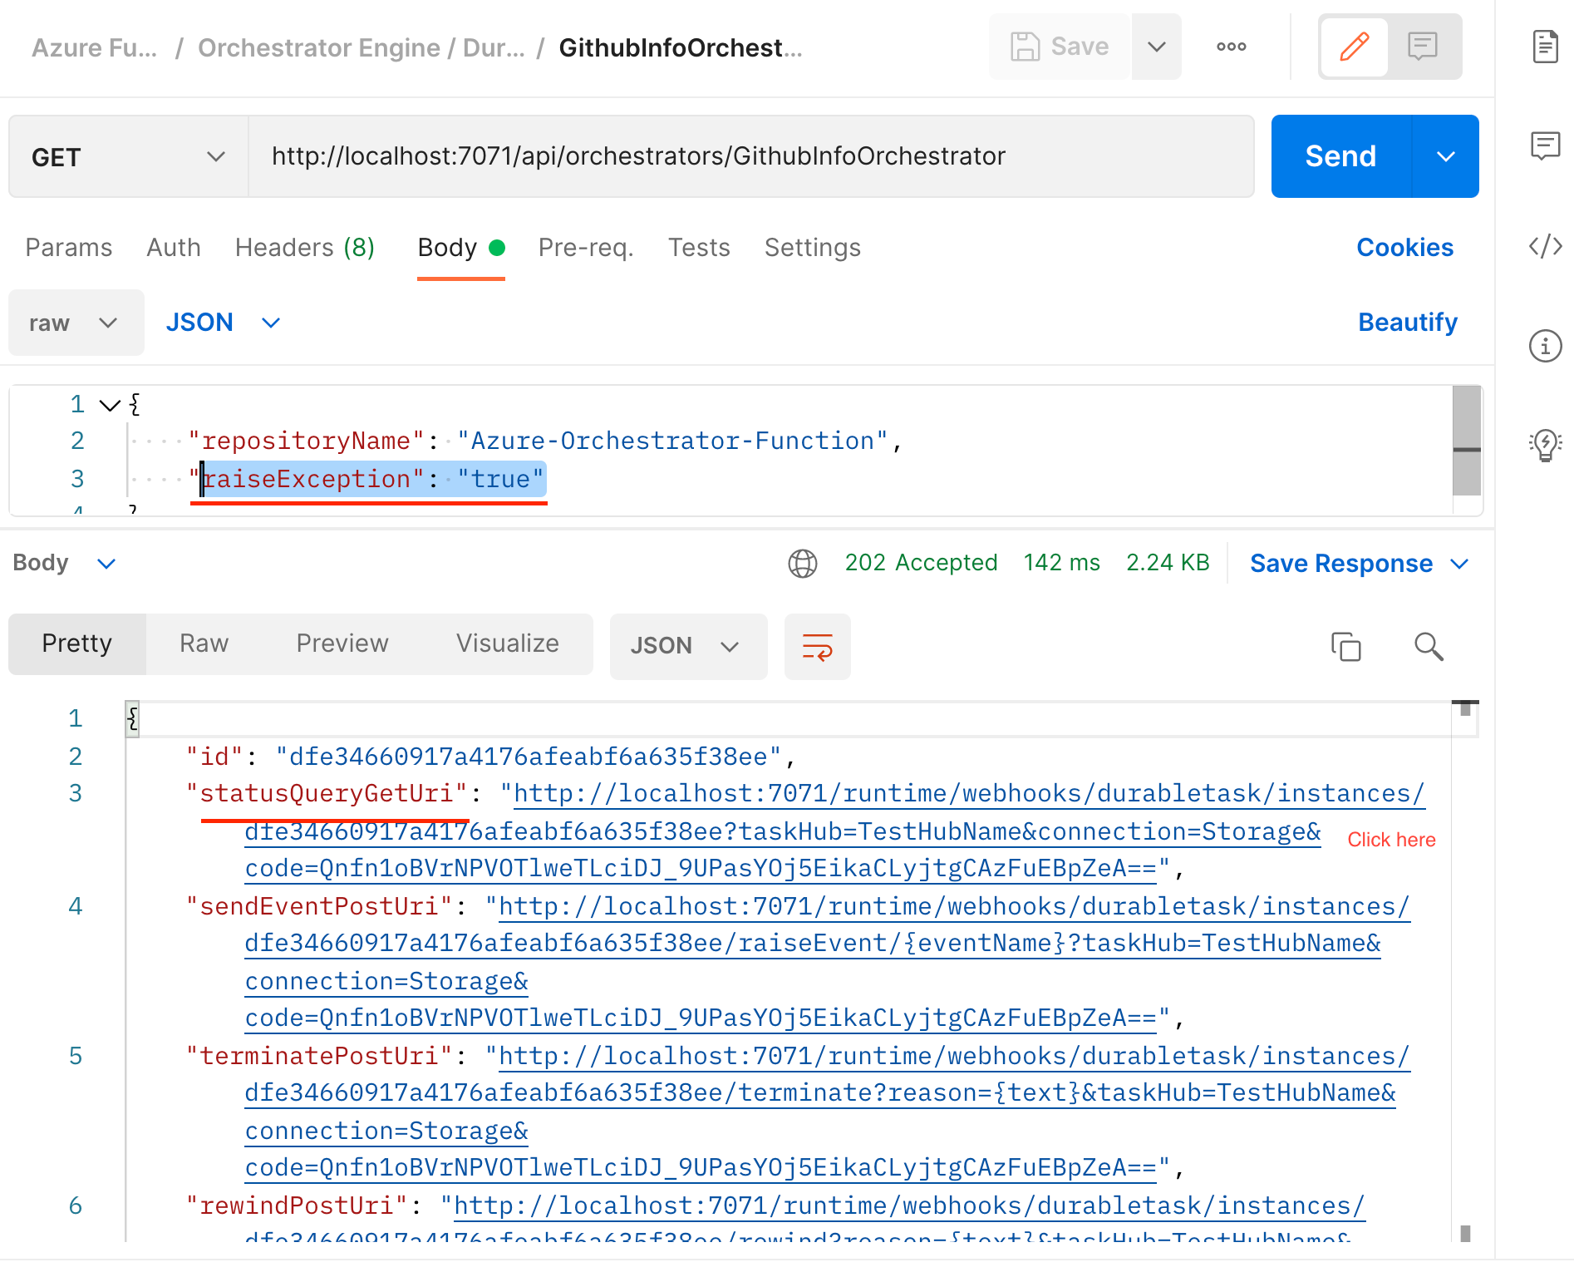

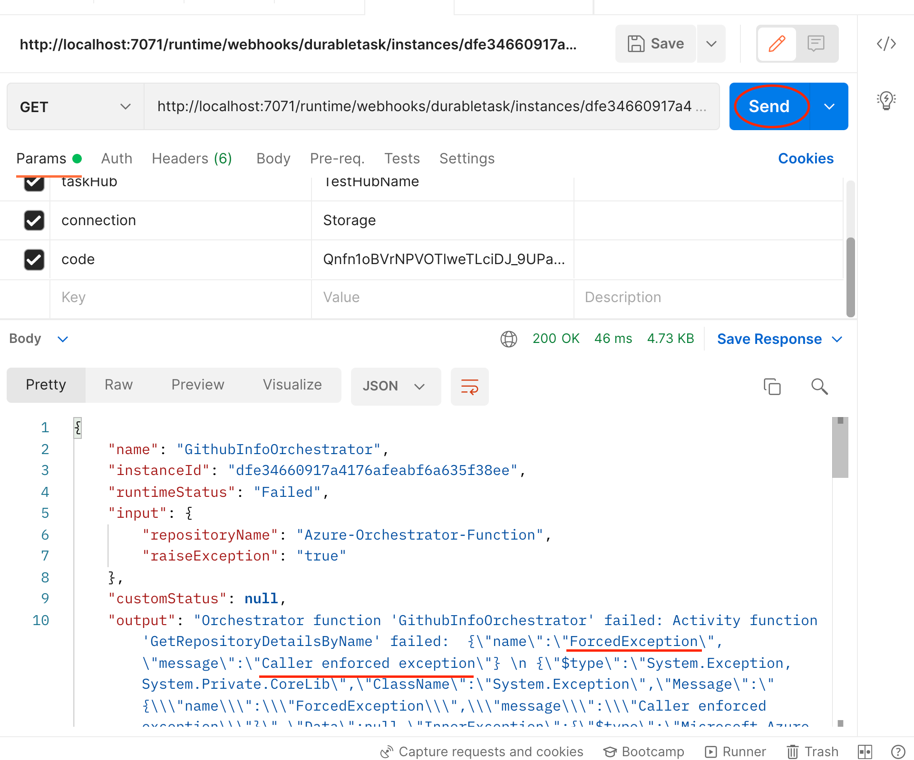

🡪 So basically we see here is final result received from orchestrator.

🡪 Now let us check behind the scenes activity.

🡪 Open Storage Explorer software

## Checking Storage explorer:

🡪 Here we basically see background activities for retry observations:

### TestHubNameInstances or DurableFunctionNameInstance:

🡪 Here we basically see number of hits done from postman.

🡪 We see each instances along with final response – Completed or Failed.

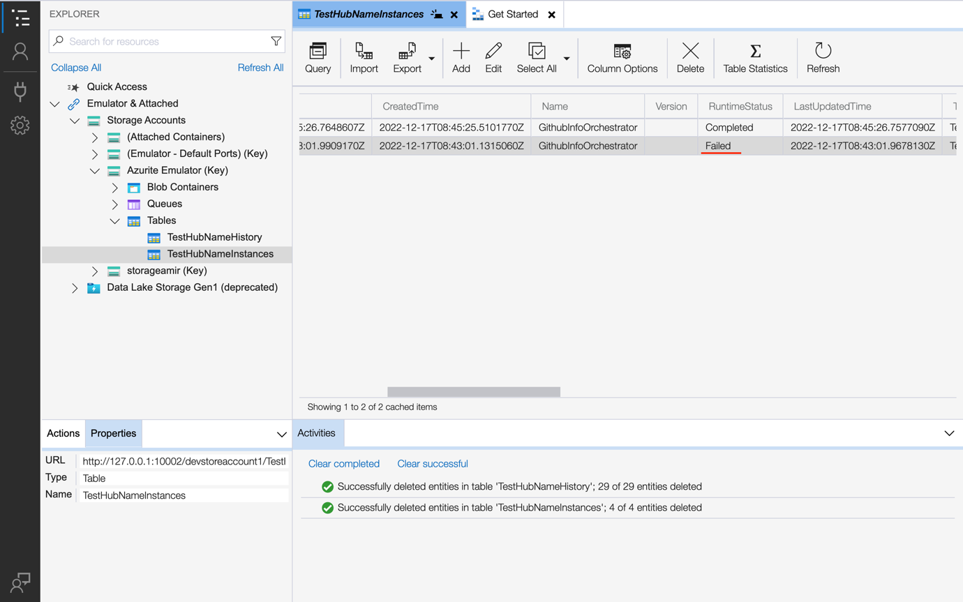

🡪 Now there are couple of requests. We will copy the instance id (or partition id of failed hit.)

🡪 Double click on row. Copy the instance id

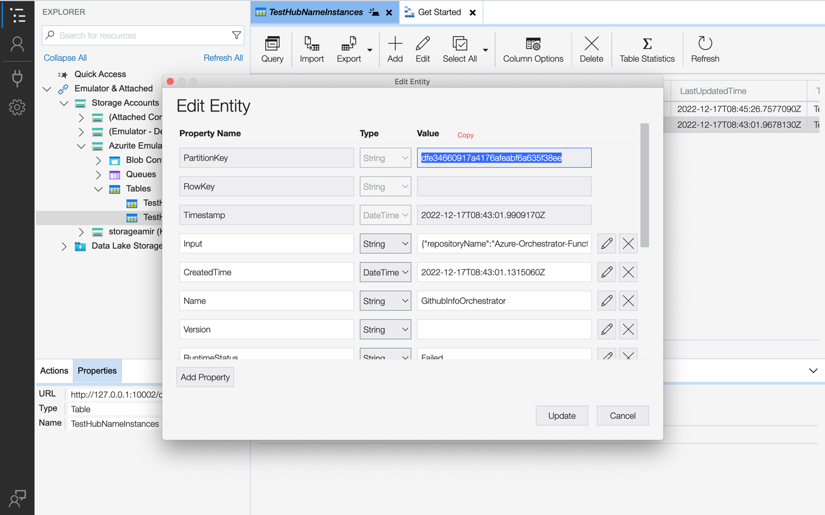

### TestHubNameHistory or DurableFunctionNameHistory:

🡪 Here we can see background activity based on instances. Let us apply query filter.

🡪 Click Query

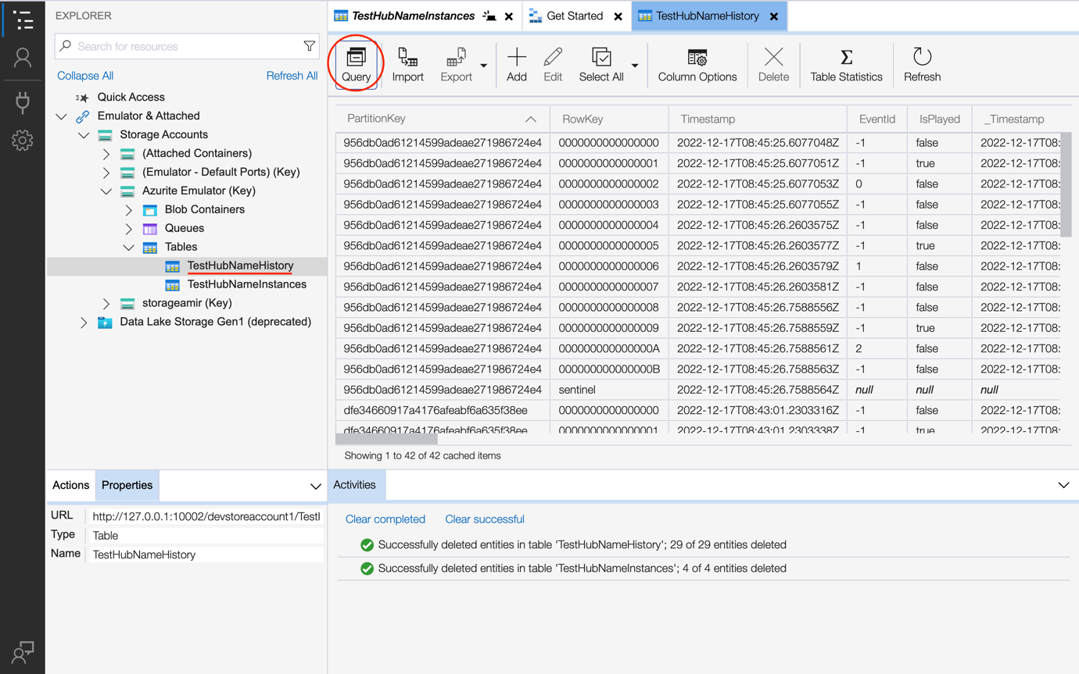

🡪 Paste the id in Partition key value. Remove other filters if any. Click Run/Play icon

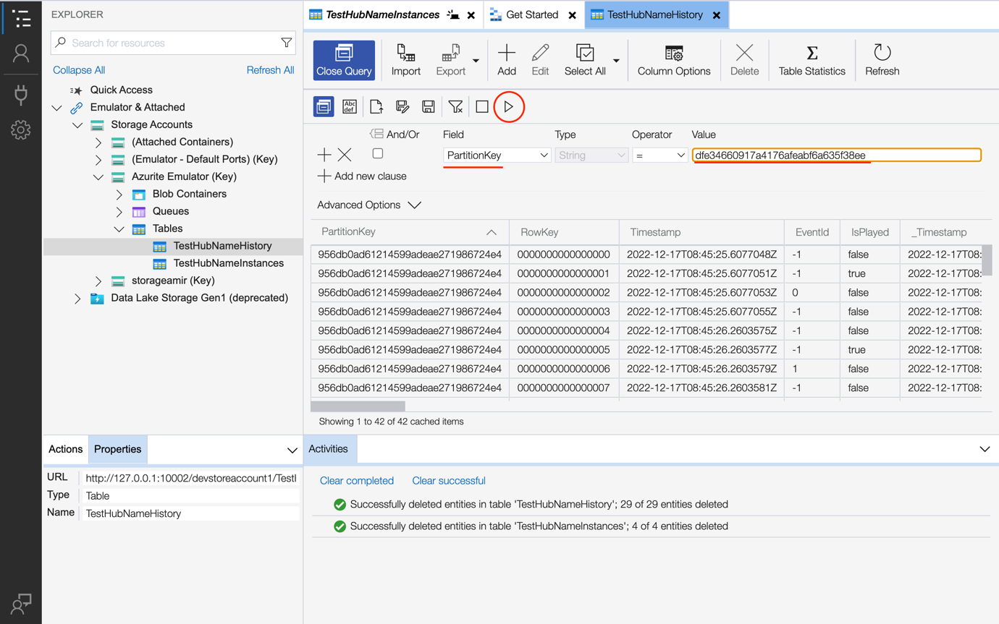

🡪 We now have this instance ID:

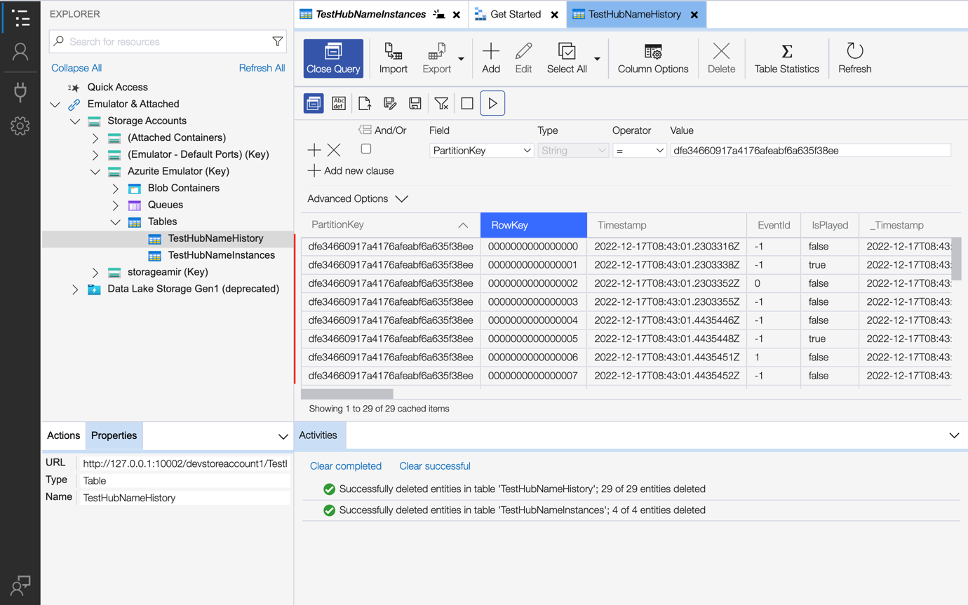

🡪 Normally latest instance is on top. Click on timestamp instance for ascending order.

🡪 So we observe 1st hit by clicking 🡪 fails

🡪 1st retry starts 🡪 fails

🡪 2nd retry starts 🡪 fails

🡪 3rd retry starts 🡪 fails, exits as max retry in code is 3

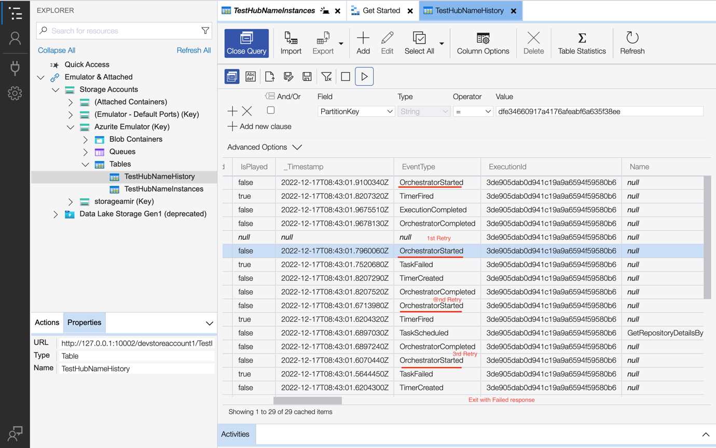

## Replay in Orchestration Engine:

🡪 We have replay function provided by durable function.

🡪 Basically for testing purpose we will make is raiseException = false in code

### GithubInfoOrchetrator - Code

Path - GithubInfoOrchestrator/index.ts

import * as df from "durable-functions";

const **orchestrator** = df.**orchestrator**(function* (context) {

const firstRetryIntervalInMilliseconds: number = 1000;

const maxNumberOfAttempts: number = 3;

const maxRetryIntervalInSeconds: number = 1000;

const retryTimeoutInMilliseconds: number = 7000;

const retryConfig: **df**.**RetryOptions** = new df.**RetryOptions**(

firstRetryIntervalInMilliseconds,

maxNumberOfAttempts

);

retryConfig.maxRetryIntervalInMilliseconds = maxRetryIntervalInSeconds;

retryConfig.retryTimeoutInMilliseconds = retryTimeoutInMilliseconds;

*// Testing purpose - making after first attempt*

if (context.df.isReplaying === true) {

context.bindingData.input.raiseException = false;

}

const userId: string = yield context.df.**callActivityWithRetry**(

"GetRepositoryDetailsByName",

retryConfig,

context.bindingData.input

);

*// Chaining response from first actitity trigger to next actitity*

context.bindingData.input.userId = userId;

const userInfo = yield context.df.**callActivityWithRetry**(

"GetUserDetailsById",

retryConfig,

context.bindingData.input

);

return userInfo;

});

export default **orchestrator**;

🡪 Let us restart the Azure function – npm start in project.

🡪 Let the hit the API:

## Testing in Postman API:

http://localhost:7071/api/orchestrators/GithubInfoOrchestrator

cURL:

curl --location --request GET 'http://localhost:7071/api/orchestrators/GithubInfoOrchestrator' \

--header 'Content-Type: application/json' \

--data-raw '{

"repositoryName": "Azure-Orchestrator-Function",

"raiseException": "true"

}'

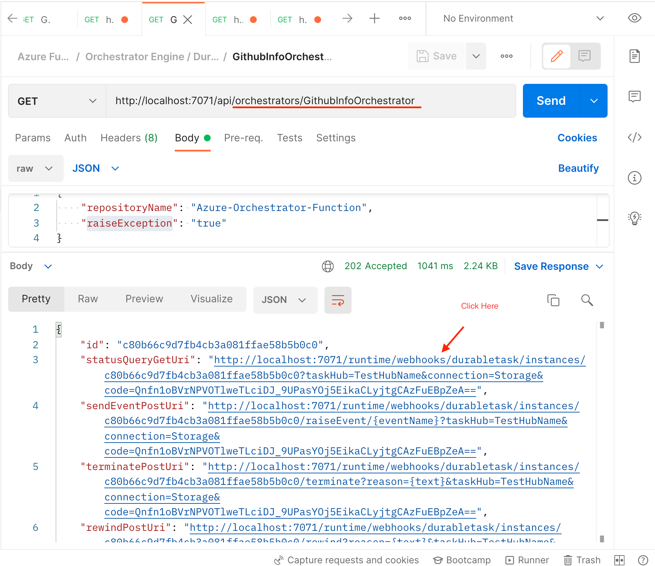

🡪 Click the link whose key is statusQueryGetUri:

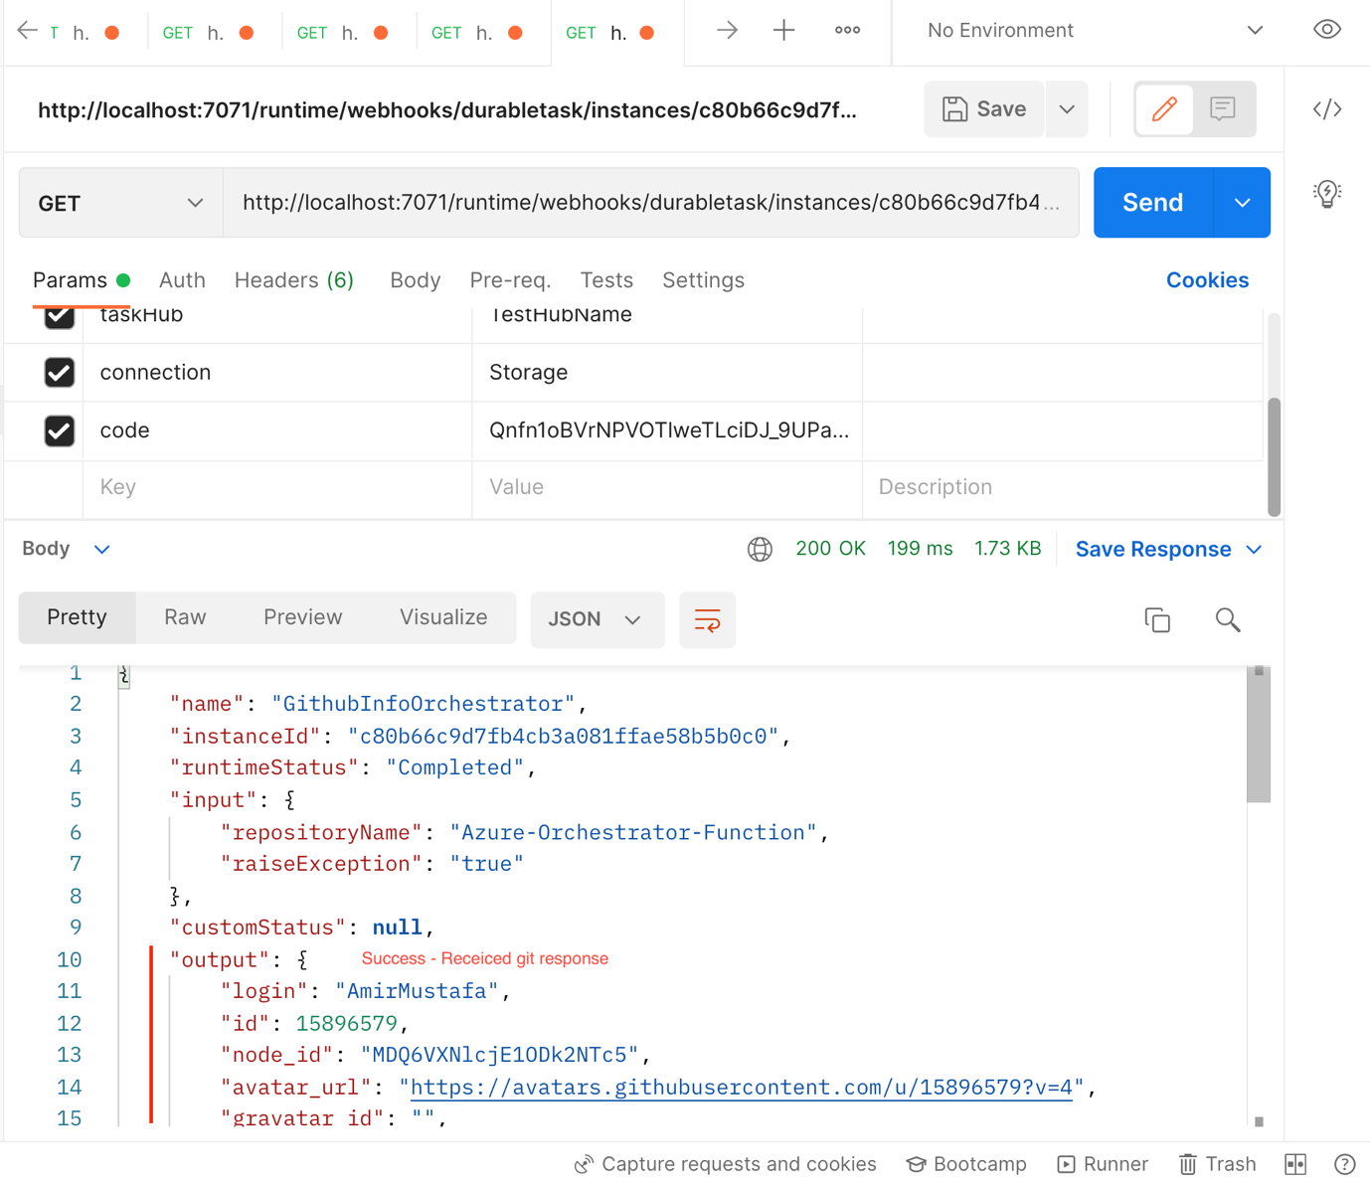

🡪 We observe this time from above screenshot response data is coming i.e. success

🡪 This happened because of replay. Let us observe in storage explorer software:

## TestHubNameHistory or DurableFunctionNameHistory:

🡪 In this table we observe final result is Completed from below screenshot.

🡪 Let us observe from History table for behind the scene orchestrator activity.

🡪 Copy the instance ID (i.e. partition key)

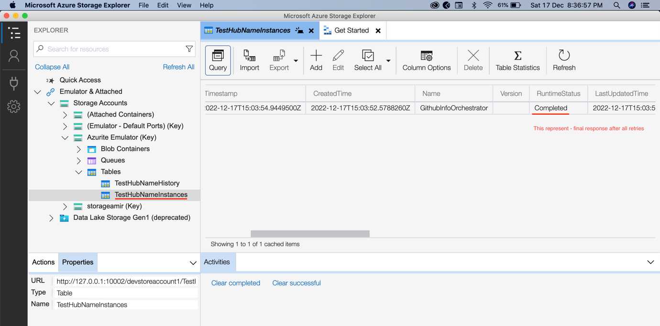

## TestHubNameHistory or DurableFunctionNameHistory:

🡪 Let us open this table and click query.

🡪 Paste the partition key. Click Run/ Play icon.

🡪 Basically we are filtering and removing previous history data

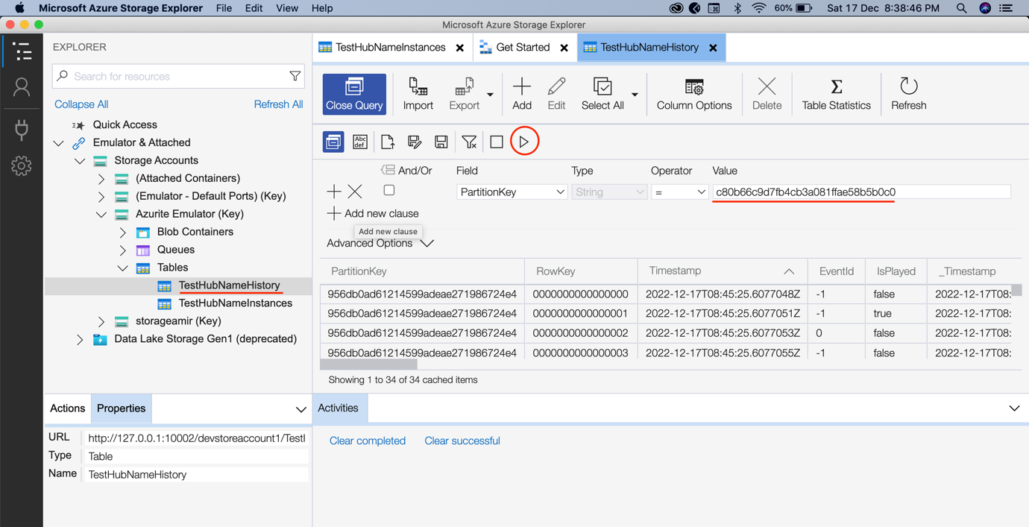

🡪 Now we have all the latest history data. i.e. starting with c80..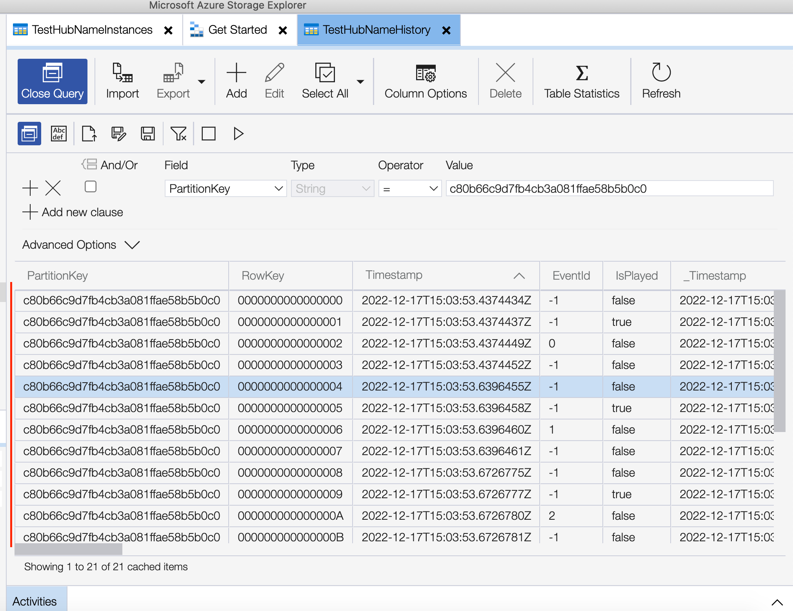

🡪 Click on Timestamp header to see in ascending order

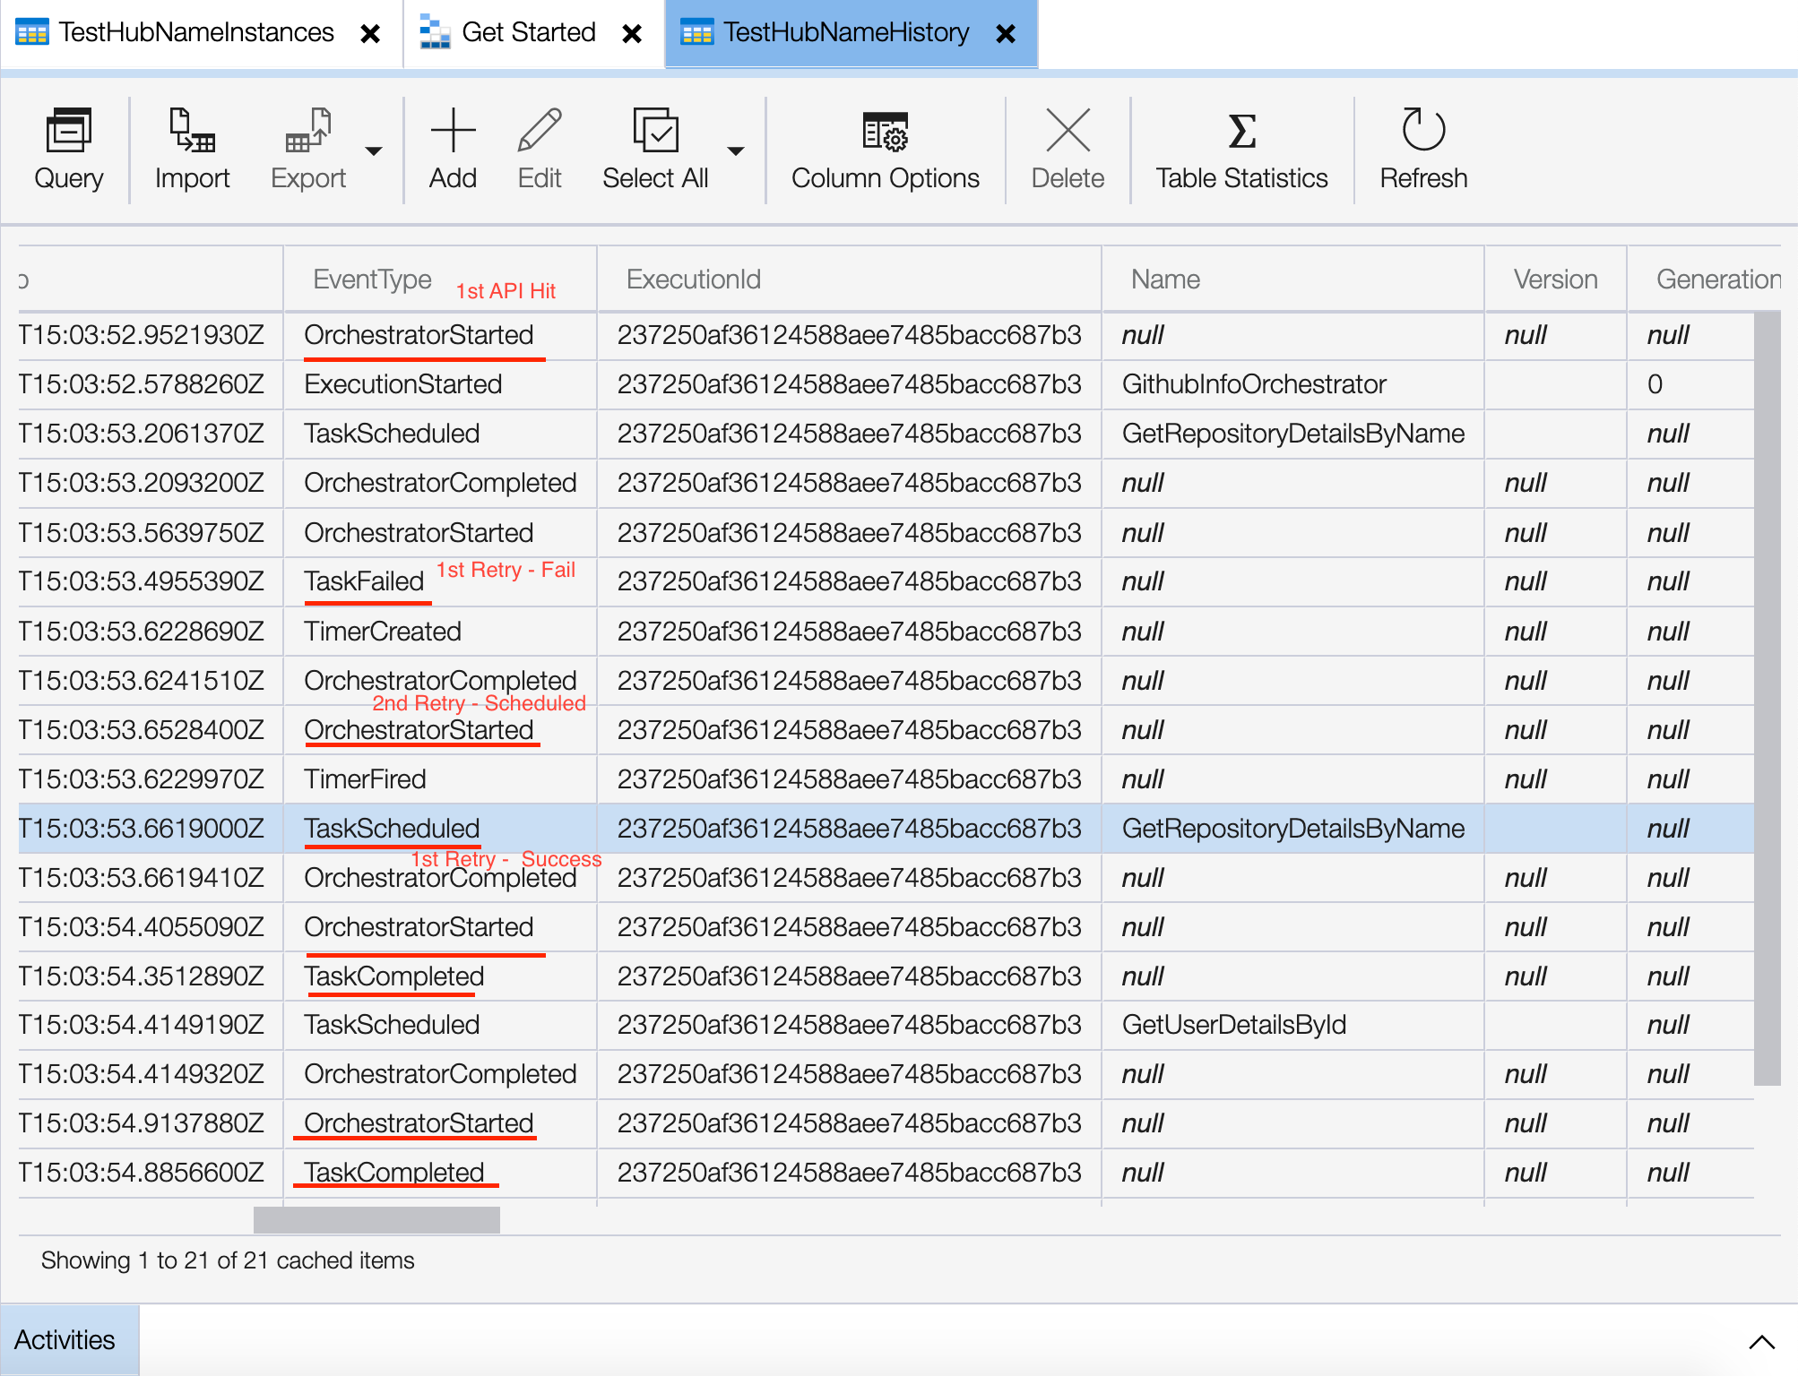

## Replay Observation - Storage Account:

Orchestrator Started – Task failed

Retry Attempt 1 – Started

Timer trigger started – scheduling

Retry 2 – Task successful

NOTE: Every Retry attempt will trigger timer function that will retry

# 7. Circuit Breaker | Timeout Feature:

🡪 We have seen timeout function triggers automatically on retry

🡪 Is there a way we can make timer trigger handy – answer is yes

🡪 We will implement timeout feature that will timeout activity trigger if it crosses some specified seconds

🡪 First we have converted from retry to plain

Tsconfig.ts

As moment uses old es package.

{

"compilerOptions": {

"module": "commonjs",

"target": "es6",

"outDir": "dist",

"rootDir": ".",

"sourceMap": true,

"strict": false,

"esModuleInterop": true

}

}

## GithubOrchestrator:

Path: GithubInfoOrchestrator/index.ts

import * as df from "durable-functions";

import moment from "moment";

const **orchestrator** = df.**orchestrator**(function* (context) {

const timeoutInMilliseconds: number = 3000; // SPECIFIED TIME – 3 SECONDS

const deadline = **moment**

.**utc**(context.df.currentUtcDateTime)

.**add**(timeoutInMilliseconds, "ms");

const timeoutTask = context.df.**createTimer**(deadline.**toDate**());

// Activity 1 – not yielding

const repositoryDetailsTask = context.df.**callActivity**(

"GetRepositoryDetailsByName",

context.bindingData.input

);

*// Race between Activity Trigger 1 and timeout*

const winner = yield context.df.Task.**any**([

repositoryDetailsTask,

timeoutTask,

]);

if (winner === repositoryDetailsTask) {

context.**log**("Repository information fetched before timeout");

timeoutTask.**cancel**();

const userId = repositoryDetailsTask.result;

context.bindingData.input.userId = userId;

} else {

context.**log**("Repository information call timed out !!");

throw new **Error**("Repository information fetched before timeout !!");

}

*// Activity Trigger 2*

const userInfo = yield context.df.**callActivity**(

"GetUserDetailsById",

context.bindingData.input

);

return userInfo;

});

export default **orchestrator**;

🡪 The activity trigger in which we want to implement timer, remove yield and assign to a variable.

🡪 context.df.Task.any – races between array of activity1 and timeout

🡪 if timeout wins halt code, throw error, other wise continue to activity 2

## Adding delays/sleep for testing:

GetRepositoryDetailsByName

Path: GetRepositoryDetailsByName/index.ts

🡪 Here we delay the code purposefully and test

import { AzureFunction, Context } from "@azure/functions";

import { Octokit } from "@octokit/core";

const **activityFunction**: **AzureFunction** = async function (

context: **Context**

): **Promise**<string> {

await **sleep**(7000);

const octokit = new **Octokit**();

const query = `${context.bindingData.repositoryName.**toString**()} in:name`;

const searhResult = await octokit.**request**("GET /search/repositories", {

q: query,

});

context.**log**(

"respository name ===> ",

context.bindingData.repositoryName,

context.bindingData

);

context.bindingData.repositoryName = context.bindingData.repositoryName;

context.**log**("search data ==>", searhResult);

const exactMatch = searhResult.data.items.**find**(

(item) => item.name === context.bindingData.repositoryName.**toString**()

);

context.**log**("exactMatch ==>", exactMatch);

context.bindingData.repositoryName = context.bindingData.repositoryName;

return exactMatch.owner.login;

};

async function **sleep**(ms: number) {

return new **Promise**((**resolve**) => **setTimeout**(**resolve**, ms));

}

export default **activityFunction**;

## Postman API:

http://localhost:7071/api/orchestrators/GithubInfoOrchestrator

Body:

{

"repositoryName": "Azure-Orchestrator-Function"

}

cURL:

curl --location --request GET 'http://localhost:7071/api/orchestrators/GithubInfoOrchestrator' \

--header 'Content-Type: application/json' \

--data-raw '{

"repositoryName": "Azure-Orchestrator-Function"

}'

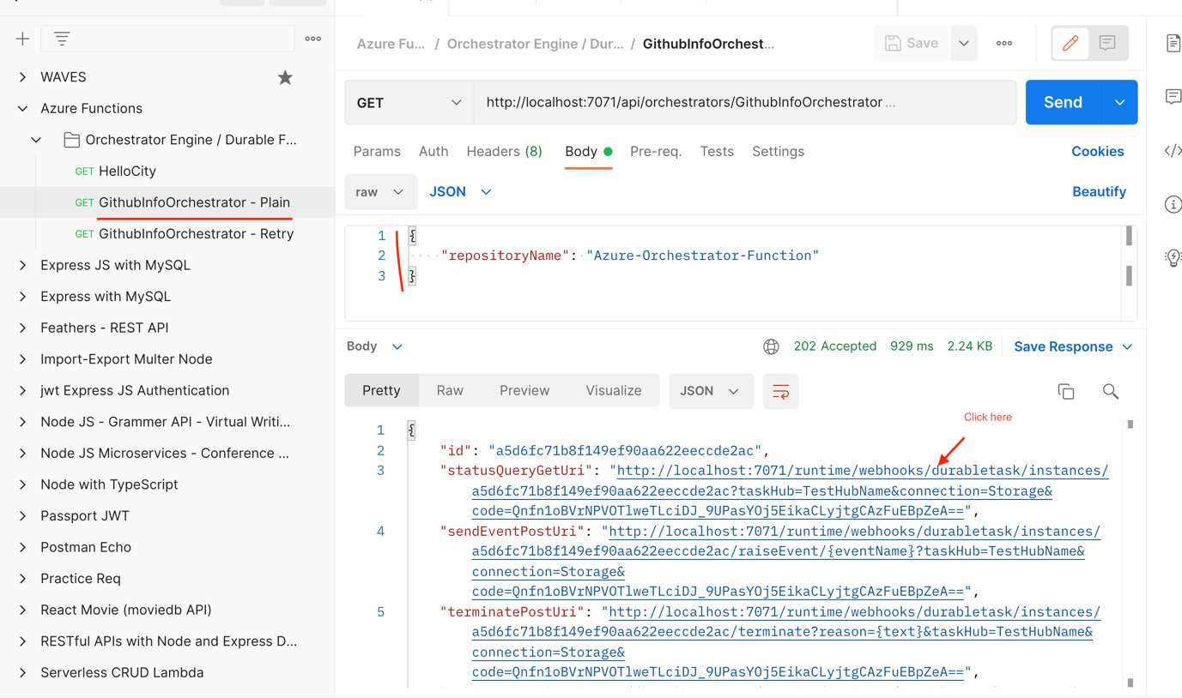

🡪 We get timeout error as we have delayed 7 seconds in activity and timeout – 3 seconds

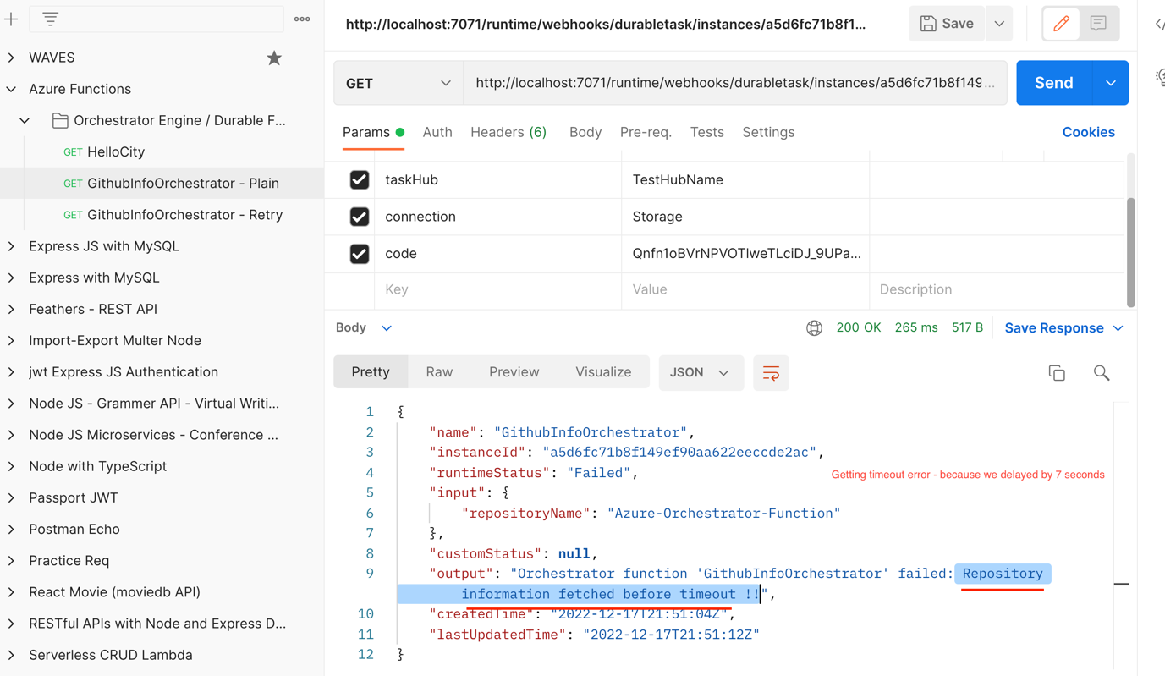

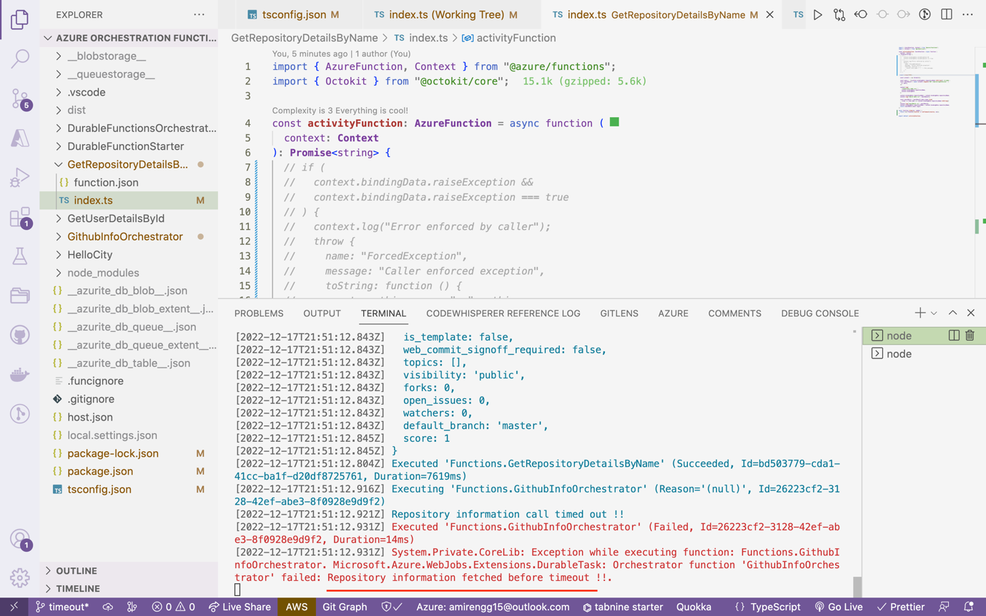

🡪 Now let remove delay in activity trigger, restart Azure function and retry

Commit: <https://github.com/AmirMustafa/Azure-Orchestrator-Function/commit/7935f454ab5dc6d60b2cea5fb89c63d0f09171a5>

GithubRepositoryDetails:

import { AzureFunction, Context } from "@azure/functions";

import { Octokit } from "@octokit/core";

const **activityFunction**: **AzureFunction** = async function (

context: **Context**

): **Promise**<string> {

*// await sleep(7000); // Commented Delay*

const octokit = new **Octokit**();

const query = `${context.bindingData.repositoryName.**toString**()} in:name`;

const searhResult = await octokit.**request**("GET /search/repositories", {

q: query,

});

context.**log**(

"respository name ===> ",

context.bindingData.repositoryName,

context.bindingData

);

context.bindingData.repositoryName = context.bindingData.repositoryName;

context.**log**("search data ==>", searhResult);

const exactMatch = searhResult.data.items.**find**(

(item) => item.name === context.bindingData.repositoryName.**toString**()

);

context.**log**("exactMatch ==>", exactMatch);

context.bindingData.repositoryName = context.bindingData.repositoryName;

return exactMatch.owner.login;

};

async function **sleep**(ms: number) {

return new **Promise**((resolve) => **setTimeout**(resolve, ms));

}

export default activityFunction;

